**BIG DATA BAYWATCH: CALIFORNIA FLOODS EDITION**

A Project Report

Presented to

DATA 228

Spring, 2023

By,

Sachin Kumar Srinivasa Murthy

Sangamithra Murugesan

Siddharth Solanki

Maharsh Soni

Sonali Arcot

May 7, 2023

Copyright © 2023

[DATA228, Spring 2023, Team Chai Tea Latte]

ALL RIGHTS RESERVED

**ABSTRACT**

Recently, the severity and frequency of natural disasters, particularly flooding, have increased due to climate change. Over the past decade, California has witnessed an average of a 34% YoY increase in flooding events. However, due to a lack of awareness, the number of flood insurance policies sought in the same period has dropped by 5.8%. The latest 2023 floods in California resulted in financial losses worth $31 billion, six times higher than the national average of flood-related financial losses since 2009. This project recognizes that heavy rains stand as the leading cause of flooding events and utilize climate (rainfall) data and flooding events data from NOAA, as well as insurance policies data from FEMA, to develop a data warehouse that can help in efficient analytics and deriving data-driven insights for better-informed flood-related policy-making. This project leverages the big data analytics engine Spark with Python Programming on the Google Colaboratory VMs for exploratory data analytics and the data analytics platform, Tableau for creating compelling visual dashboards. AWS technologies, such as S3 for data storage, GLUE for ETL operations, Redshift for data warehousing, and Redshift Query Editor for query data analytics, were employed. Furthermore, this project provides an end-to-end comprehensive real-world big data solution by building a web portal with Single-Sign-On functionality built with Google Firebase, allowing authorized users to download the Redshift data tables and view the tableau dashboards. Overall, the proposed big data platform offers a complete one-stop analytics solution for addressing the challenges posed by flooding events in California and demonstrates the feasibility of big data analytics in mitigating risks associated with natural disasters through data-driven insights for policy-making.

**ACKNOWLEDGEMENTS**

We would want to extend our sincere gratitude to everyone who helped our Data 228 - Big Data Baywatch project be completed successfully. Our warmest gratitude extend to in particular to our Professor Andrew Bond, whose unwavering support and knowledgeable advice were crucial in forming our technique and sharpening our analyses. His lectures and discussions were extremely helpful in spurring us on to consistently pursue excellence.

We are also appreciative of the Federal Emergency Management Agency (FEMA) and the National Oceanic and Atmospheric Administration (NOAA) for providing us access to the data sources required to conduct the study. Our analysis has been made possible by their dedication to open data projects and information sharing, and we are mindful of the enormous effort and resources needed to maintain these data sources.

We would like to express our gratitude to the Department of Data Science at the San José State University, College of Professional and Global Education, for giving us the chance to work on this project and for providing us with the tools we needed to finish it. We appreciate the help and inspiration from our knowledgeable classmates and were able to overcome challenges and stayed committed to our project because to their never-ending encouragement and confidence in our abilities.

**Table of Contents**

Chapter 1 Introduction

1.1 Project goals and objectives

1.2 Problem and motivation

1.3 Project application and impact

1.4 Project results and deliverables

1.5 Market research

1.6 Project report structure

Chapter 2 Project Background and Related Work

2.1 Background and used technologies

2.2 State-of-the-art technologies

2.3 Literature survey

Chapter 3 System Requirements and Analysis

3.1 Domain and business requirements

3.2 Customer-oriented requirements

3.3 System function requirements

3.4 System behavior requirements

3.5 System performance and non-functional requirements

3.6 System context and interface requirements

3.7 Technology and resource requirements

Chapter 4 System Design

4.1. System architecture design

4.2. System data and database design (for software project only)

4.3. System interface and connectivity design

4.4. System user interface design (for software project only)

4.5. System component API and logic design (for software project only)

4.6 System design problems, solutions, and patterns

Chapter 5 System Implementation

5.1. System implementation summary

5.2. System implementation issues and resolutions

Chapter 6 System Testing and Experiment

6.1 Testing and experiment scope

6.2 Testing and experiment approaches

6.3. Testing report (or case study results)

Chapter 7 Conclusion and Future Work

7.1 Project summary

7.2 Future work

**Chapter 1. Introduction**

**1.1 Project Goals and Objectives**

The project aims to leverage Big Data Technologies such as Spark and AWS solutions to create a data-driven solution for spreading awareness on the significance of flood insurance, create flood-emergency preparedness by assessing the probability and severity of flooding events in California's counties, and drive administration plans for positioning climate monitoring stations in counties with high flood risk. Although the project offers a solution to derive insights at a county-level granularity, its objective is to provide a proof-of-concept of a cost-efficient big data analytics platform to monitor floods, weather, and flood insurance transactions in a unified data warehouse at any level of granularity and provide insights to drive data-driven policymaking.

**1.2 Problem and Motivation**

In California, floods are increasing in frequency and severity over the years, and insurance policy transactions are declining at the same time. The total estimated cost of California Floods in 2023 is estimated to be 31 billion U.S. dollars [2], which is 6 times higher than the national average cost over the past decade [3]. There is a lack of awareness of the importance of flood insurance programs to avoid monetary losses. The Flood Insurance Rate Maps (FIRMs) are ineffective as they are required to be updated once every five years [4]. Additionally, if there are intermediate changes to FIRMs due to natural calamities, it takes up to 90 days for the approved changes to reflect [5]. Outdated flood zone hazard maps are no longer a viable option to suggest to California residents the dynamically changing and immediate importance of flood insurance policies for their property. There is a need for a real-time big data analytics monitoring system to provide quick and dynamically evolving actionable insights on the probability of floods causing damages to personal properties for residents in a county to take early action, and subscribe to a flood insurance program. Such early insights can help California residents to overcome catastrophic floods, without a significant dent in their finances.

The project aims to deliver three academic/ technical contributions. First, it proposes a big data analytics system design that is specifically built to process and analyze large volumes of climate, and flood insurance transaction data in real-time using advanced data processing techniques to provide accurate and timely updates to the insights. Second, the data warehouse solution developed consists of tables that can help in the creation of new flood risk assessment models to predict the likelihood of floods in a given county, based on climate movements. The constant monthly updates to the data warehouse can help in developing the prediction models in a CI/CD pipeline to reflect changes in the environment and climate. Finally, the insights provided in the project through tableau dashboards aim to inform the development of new flood insurance policies and programs that can be customized to the needs of California residents and encourage more people to subscribe to flood insurance based on the timely updated insights and predictions provided by the real-time big data analytics system.

**1.3 Project Application and Impact**

The application of this project is aimed at providing visual insights, and analytics for informing on the probability and severity of floods in California's counties, promoting the adoption of flood insurance programs, and driving policy-making decisions to mitigate the risks associated with floods. The project's impact is twofold - technical and societal.

From a technical perspective, the proposed big data analytics system design, which uses advanced data processing techniques, can be extended to not just California but also other states of the country. Additionally, the system design also supports analytics at low granular levels such as cities, or ZIP Codes. Furthermore, the system design can also be leveraged for other natural disaster risk management domains like wildfires, hurricanes, and earthquakes.

From a societal perspective, the analytical results of the project can have a significant impact on the residents of California to take early action, get insured, and reduce financial losses. Additionally, the insights from the project can help drive policy-making decisions to create flood insurance programs that are more accessible and tailored to the needs of California residents, set up additional monitoring systems in counties based on the frequency and severity of flooding events to aid better data capture for analytics-driven decision making.

**1.4 Project Results and expected deliverables**

The project proposes a real-time big data analytics platform to process and analyze large volumes of climate and flood insurance transaction data. The system utilizes advanced data processing, modeling, and analytics techniques to provide accurate and timely updates to the insights. The data warehouse solution developed consists of tables in a relational model that can help create new flood risk assessment models to predict the likelihood of floods in a given county based on climate movements. The constant monthly updates to the data warehouse can help develop the prediction models in a CI/CD pipeline to account for the most recent changes in the climate.

The project's deliverables include a detailed report containing actionable components such as system design, methodology, results, and plan documentation. Additionally, the project will provide a web portal with Single-Sign-On functionality built with Google Firebase and allow authorized users to download the Redshift data tables. The portal also allows viewing the tableau dashboards to consume insights without SSO. It offers a user-friendly interface for policymakers, researchers, industry professionals, and California residents to access insights into flood risks and flood insurance transaction trends. Finally, the project code is documented and delivered on GitHub [7], which includes the data processing pipeline from collection to cleaning and modeling tables and tableau visualization dashboard files for reference and future development.

**1.5 Market research**

There are four distinct data visualization products offered by FEMA and NOAA organizations. These products have pros and cons associated with them, and all of these products do not offer a one-stop comprehensive solution to inform on the lack of insurance policy purchases to mitigate flood-related risks. There is no concrete information available on the big data technology stack employed in the construction of these products. However, some information on the data visualization tools utlilized is available in the public domain. In the following paragraphs of this section, each of the four distinct products and its associated pros and cons are discussed in brief. Additionally, screenshots of the products are also provided.

FIRMs (Flood Insurance Rate Maps) are a product of the Federal Emergency Management Agency (FEMA) [8]. It provides flood insurance rate zones for geographic areas. These maps are used to determine flood insurance requirements and rates for housing and retail properties [9]. The drawback of this product is that it is not frequently updated as shown in Figure 1. Officially, it is required to be updated at least once in five years, and in most cases, it is not updated for decades. Furthermore, these rate maps, are not informative, user-friendly, and informative to the general audience as shown in Figure 2 and Figure 3.

**Figure 1** Infrequent updates to Flood Insurance Rate Maps

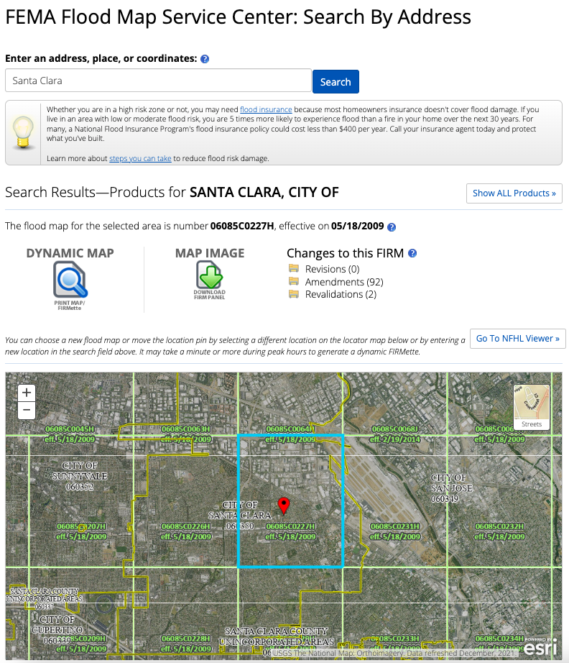

**Figure 2** Lack of granular information for comparing risks across Counties or States

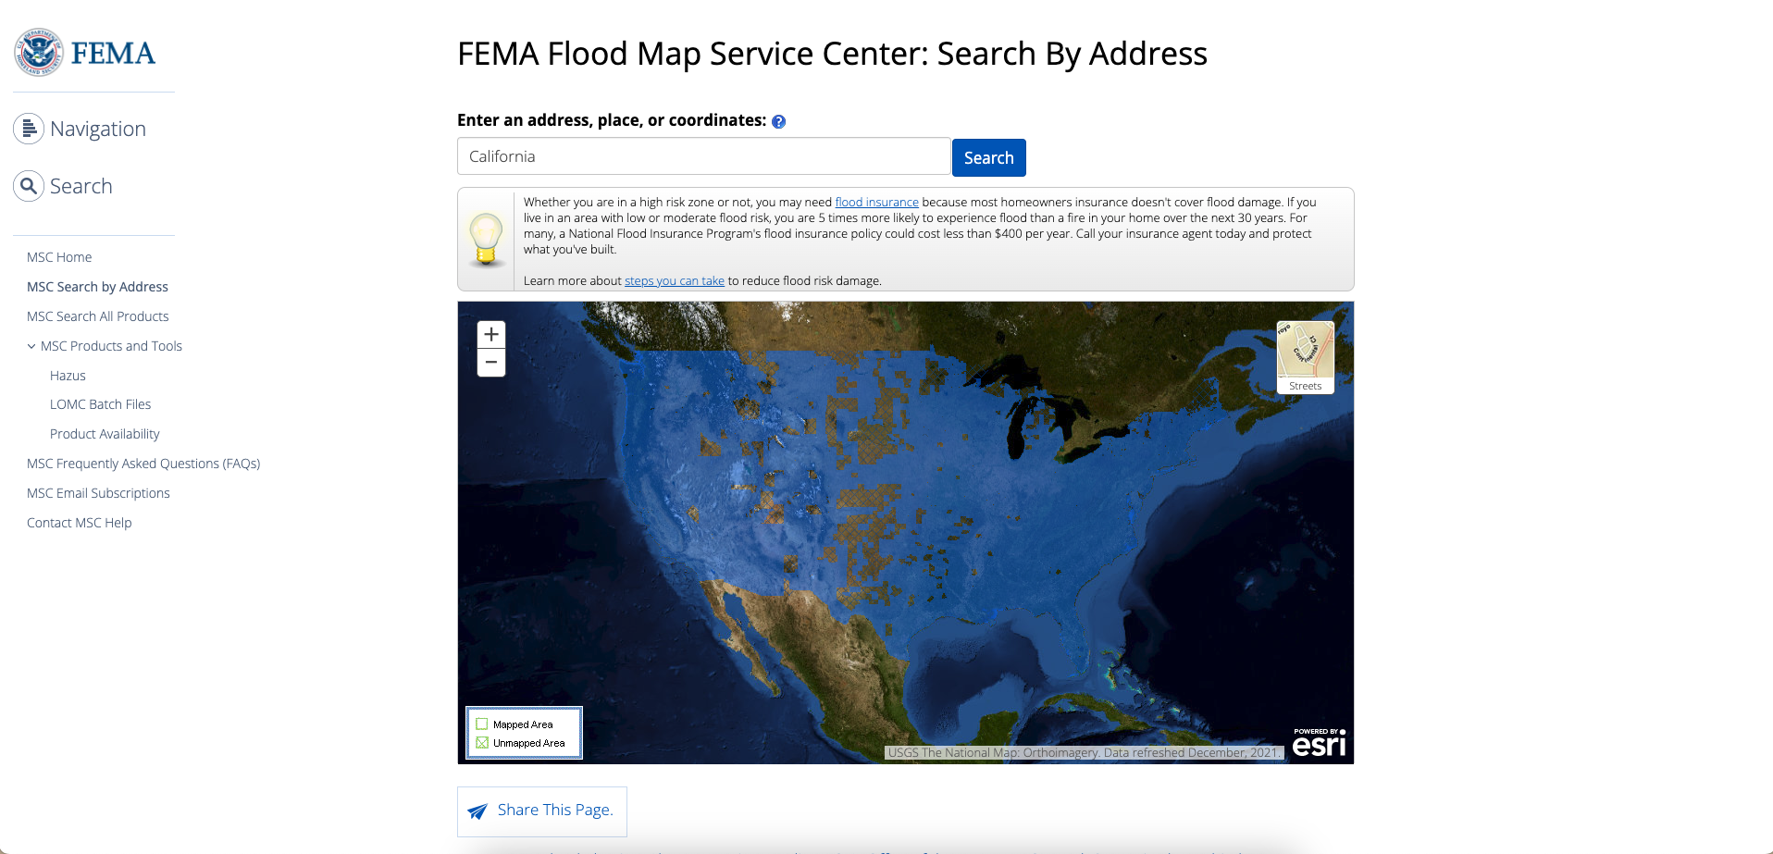

**Figure 3** Lack of interactivity to compare the intensity of flood insurance rate map regions

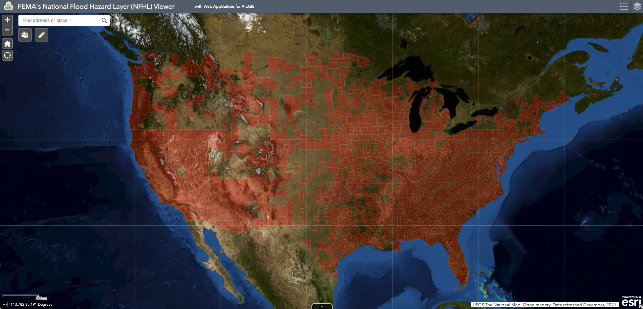

FEMA National Risk Index (NRI) map [10], provides a comprehensive view of natural hazard risks across the United States, at State, County, and Census-tract level granularity. The NRI map considers multiple hazards, including floods, and uses data visualization to inform users about the counties with the greatest risks of natural hazards as shown in Figure 4. It allows to filter for the type of hazard, and floods, and access visual insights as shown in Figure 5. However, there are some limitations to this product. Firstly, the interactivity of the map does not allow a quick comparison of hazard index values by just hovering over the map. Secondly, the values are indexed values, and they do not offer actual information such as numbers or floods. Thirdly, there is a lack of integration of flood-insurance policies sought by the counties to offer more actionable insights. Finally, there is a lack of a time-series scale to visually interpret how the severity of flood risk has changed over the years across the regions.

**Figure 4** FEMA National Risk Index Map

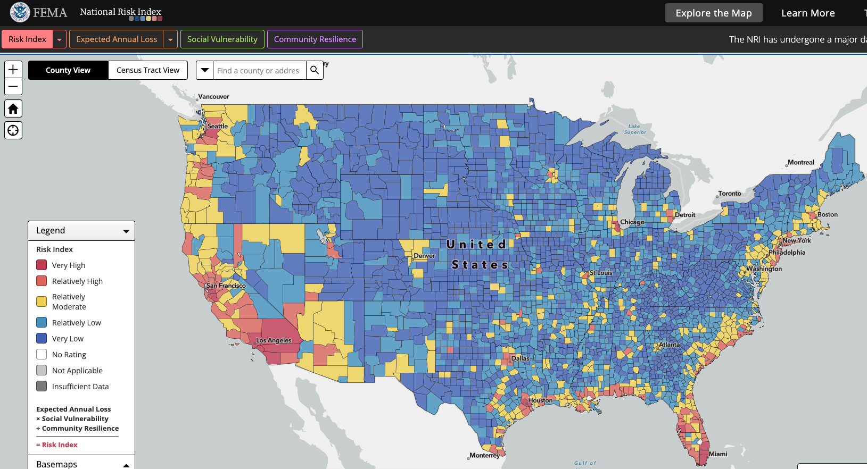

**Figure 5** Interactivity of FEMA NRI Map

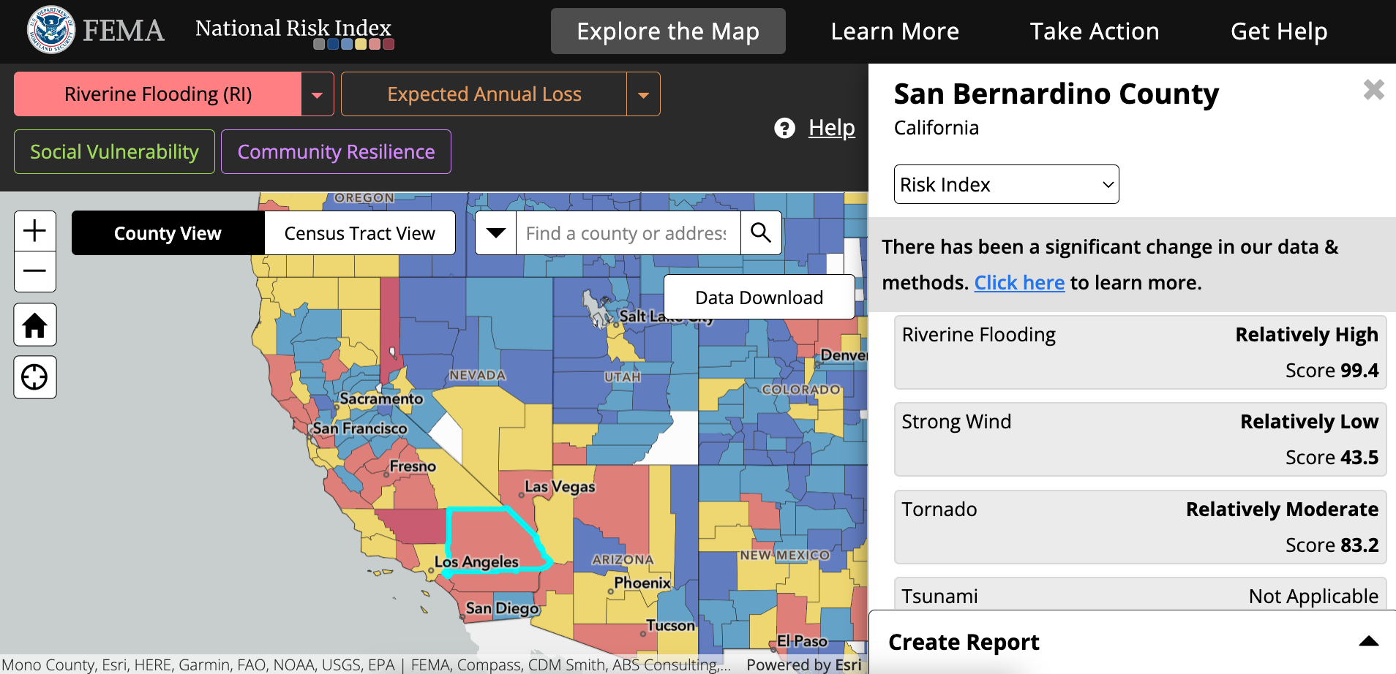

FEMA also provides historical flood risks and costs related data visualizations [11] using Tableau [12] for all the states of the USA, as shown in Figure 6. These are highly informative and achieve the objective of raising awareness and promoting flood insurance policies. There are certain limitations to this product. First, the product offers insights only till 2019, and recent changes are not captured. Second, the number of floods in this product is not the true total number of floods in the county in a year. The FEMA product only considers floods for which insurance claims have been sought. Finally, despite having the information related to the count of policy claims sought, there is no granular information offered, and the product just mentions the average insurance payout offered to flood claims across California from 1996 to 2019. Also, there is no information provided to suggest if the average number mentioned is adjusted to inflation.

**Figure 6** FEMA Historical Flood Risks and Costs, Tableau Dashboards

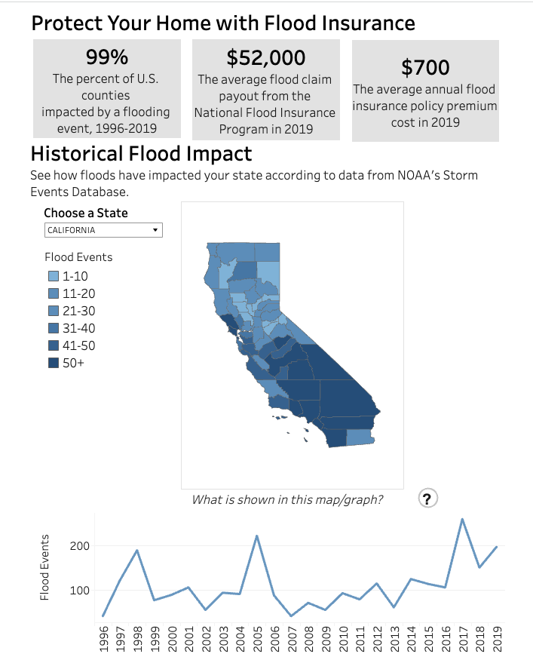

The National Oceanic and Atmospheric Administration (NOAA) also offers flood mapping and data services called the NOAA Billion-Dollar Weather and Climate Disasters Mapping [13]. It provides visual insights on the CPI-adjusted cost of weather and climate-related disasters, including floods at the State and National levels, refer Figure 7. It also offers Weather and Climate Hazard Vulnerability insights at a more granular county level, refer Figure 8. This product allows one to check the insights for a particular year or a time frame. It also offers an option to filter for types of climate disasters and study them individually. The only limitation of this product is the lack of comparative information on disasters, and climate-risk insurance transactions side by side.

**Figure 7** NOAA Billion Dollar Disaster Cost Map

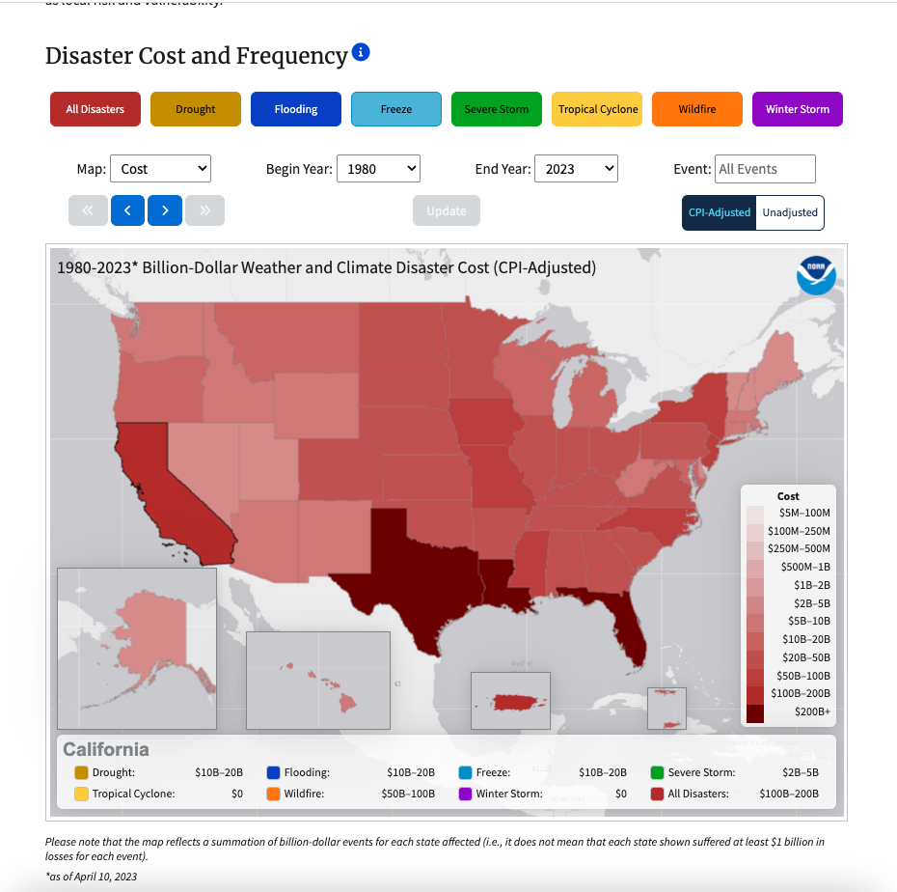

**Figure 8** NOAA Billion Dollar Climate Risk and Vulnerability Map

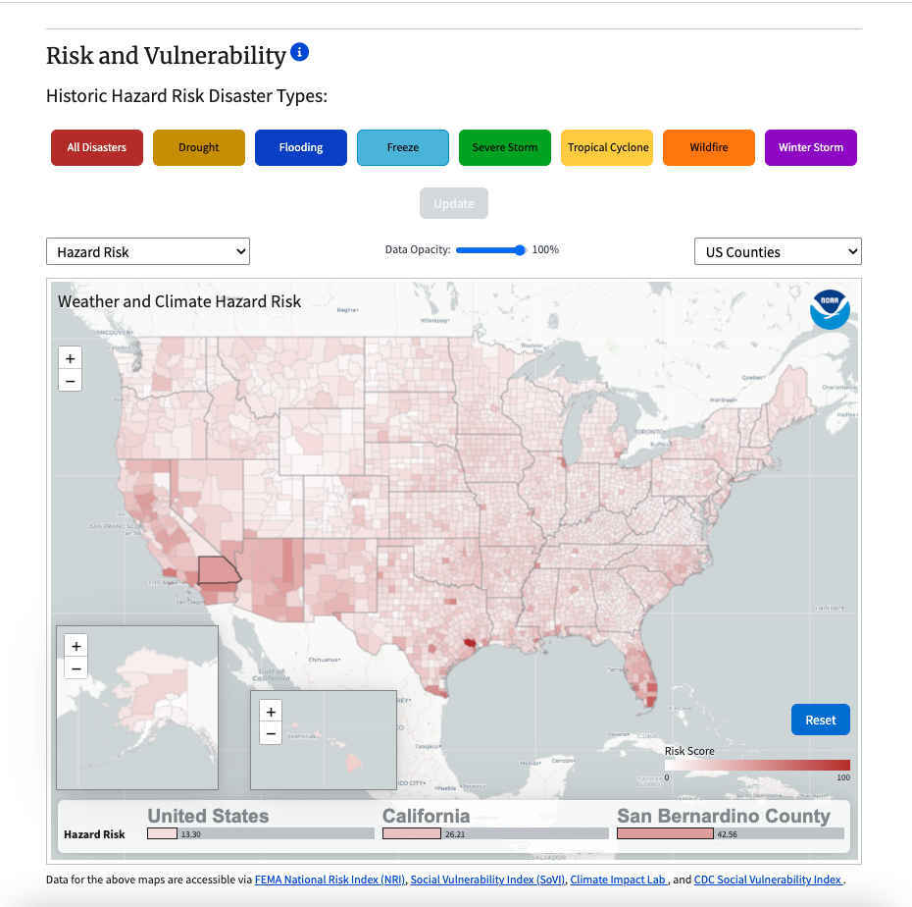

The insights gained from this market research helped us in identifying gaps in the existing solutions, and fill them by developing a one-stop solution that can offer more compelling and actionable data-driven insights for effective policy-making related to flood insurance programs, flood and climate monitoring stations, and flood disaster preparedness.

**1.6 Project Report Structure**

Building upon the Introduction from sections 1.1 to 1.5 of Chapter-1, the rest of the project report structure is organized as follows:

In Chapter 2, the project background and related work, including the technologies used, state-of-the-art technologies, and a literature survey is presented. Chapter 3 covers the big data platform’s system requirements and analysis. This includes domain and business requirements, customer-oriented system requirements, system functional and behavior requirements, system performance and non-functional requirements, system context and interface requirements, and technology and resource requirements. Chapter 4 discusses the system design. This includes system architecture design, database design, system interface, and connectivity design, system user interface design, system component API and logic design, and system design problems, solutions, and patterns.

In Chapter 5, the system implementation summary is provided. This includes a detailed report on system implementation issues and resolutions and the technologies and tools used. In Chapter 6, the system testing and experiments documentation is included. Finally, Chapter 7 of this report concludes the study with discussions on future work.

**Chapter 2. Background and Related Work**

**2.1 Background and used technologies**

The data sources leveraged to build the big data analytics platform stem from two sources namely NOAA, and FEMA. We collected two datasets from NOAA namely, NCEI Storm Events Database [14], and NCEI NOAA Climate Data Records [15]. The Storm Events Database provided Flood events information at an event-level granularity, and the Climate Data Records offered Daily Weather averages at Station-level. There were multiple stations in the database for each County of California. From the FEMA portal, we procured the insurance policy transaction data in California.

The tools used for developing the Big Data Analytics platform include- Google Drive, Google Colaboratory, Apache Spark, Python, AWS tools (S3, CLI- boto3, Glue, Redshift), Google Drive API, Google Firebase Authentication, HTML, CSS, JavaScript, and NodeJS. The project also implements AWS cloud concepts such as S3 replicas, S3 Archival with Glacier, ETL Crawlers, Data Warehousing, Relational Data Modelling, VPC, inbound requests to VPC, IAM roles, MFA, and SSO for efficient implementation of failure-averse, secure, and scalable big data analytics platform.

**2.2 State-of-the-art**

​​ The existing solutions offer significant insights into the flood catastrophes and their related impact but have some limitations that make them inadequate for offering a comprehensive solution to inform on the lack of insurance policy purchases to mitigate flood-related risks. The datasets of flood insurance policies, weather, and flooding events are offered by different organizations, and there is a lack of integration of these databases on a unified data warehouse platform. Refer to Table 1 below for comparisons of existing products identified in the current market, highlighting their pros and cons, and information related to the available tech stack of these products.

**Table 1** Comparison of the existing related state-of-the-art products

| Product Name | Description | Pros | Cons | Tech Stack |
| --- | --- | --- | --- | --- |
| Flood Insurance Rate Maps (FIRMs) | Provides flood insurance rate zones for geographic areas to determine flood insurance requirements and rates for properties. | Offers specific insurance rate information for properties. | Not frequently updated, lack of granularity and interactivity, not  user-friendly. | N/A |
| FEMA National Risk Index (NRI) map | Provides a comprehensive view of natural hazard risks across the  United States, at State, County, and Census-tract level granularity.  Considers multiple hazards and offers filters for hazard types. | Granular insights on natural hazard risks, and data visualization to  inform users about counties with the greatest risk of natural hazards. | Lack of interactivity for hazard index values, lack of integration  of flood-insurance policies sought, no time-series scale. | ArcGIS |
| FEMA Historical Flood Risks and Costs data  visualization | Provides historical flood risks and costs related data  visualizations using Tableau for all states of the USA. | Highly informative, raises awareness, and promotes flood insurance  policies. | Offers insights only till 2019, does not consider all floods, lack  of granular information. | Tableau |
| NOAA Billion-Dollar Weather and Climate  Disasters Mapping | Provides visual insights on CPI-adjusted cost of weather and  climate-related disasters, including floods at the state and national levels.  Offers weather and climate hazard vulnerability insights at a more granular  county level. | Provides insights for a particular year or time frame, allows  filtering for types of climate disasters. | Lack of comparative information on disasters and climate-risk  insurance transactions side by side. | ESRI ArcGIS |

**2.3 Literature survey**

There is limited research conducted on the intersection of flooding events, weather, and flood insurance policies. During this study, we referred to studies in the literature that took a similar approach but were limited to either floods, or insurance and were not at the intersection of both.

Wing et.al [17] published an article in 2019 in the nature journal. This article mentions the use of big data tools for managing flood risk across the USA. The author performs analytics on the FEMA NFIP claims records with 2 million observations on information for managing flood risk and claims that their contribution outperforms the existing federal depth-damage curves.

Kijewski-Correa et.al [18] developed a web-based visualization tool to assist the State of New Jersey’s municipal stakeholders in simulating the impact of hurricanes to inform preemptive actions that can save lives and mitigate property damage. The proposed tool’s outputs are automatically loaded into the user's dashboard through big data pipelines for visualizations of the projected wind, storm surge, and wave run-up based on the latest National Hurricane Center database to support data-driven decision-making.

Jared Weaver [19] in his Master’s thesis developed a big data tool to create flood inundation watershed mapping for the Florida Division of Emergency Management (FDEM). The effects of snowmelt and rainfall on flooding events were investigated in this study to suggest the need for real-time big data analytics for tracking climate to predict floods and take corrective actions on time to ensure minimal loss of property and lives. The project leveraged big data processing tools such as Spark and utilized ArcGIS for data visualization.

Assi et. al. [20] in an article published in Frontiers in Big Data Journal focuses on leveraging big data technologies for flood risk assessment and mitigation and presented a computational framework to evaluate the average annual loss (AAL) at the neighborhood level by occupant type for increasing first-floor height (FFH). Although this article does not place importance on the big data technology stack, it provides hints on the ease of performing data analytics on massive NOAA datasets with Big Data tools.

Donratanapat et. al. [21] developed a Web app called Flood Analytics Information System (FAIS), using Python Programming for gathering Big Data from multiple servers at scale and analyzing flooding impacts during historical and real-time events. The author tested the tool during the Hurricane Dorian flooding event in real-time to assess the viability of Big Data Analytics in aiding data-driven decision-making for handling floods in the USA. The author used historical data from USGS, and real-time streaming data from Twitter. The Big Data was modeled in a NoSQL schema on MongoDB, and the Python application was built using Django.

**Chapter 3. System Requirements and Analysis**

**3.1. Domain and business Requirements**

In line with the project goals, the domain of the proposed system is an analytics platform for natural disaster risk management. Specifically, it caters to flood risk assessment and insurance policy-making by utilizing the daily weather, insurance policy transactions, and flood events databases. From a business standpoint, the purpose of the project is to develop a cost-efficient big data analytics platform with AWS cloud technologies for processing and analyzing large volumes of data in real-time at low implementation and maintenance costs and, at the same time, offer real-time dynamically evolving insights that can help in taking quick steps to mitigate disasters. The solution aims at serving flood policy offering agencies and government agencies to design and promote custom flood insurance programs to residents of California based on the latest flood frequency and severity metrics. This proposed solution is achieved by collecting the raw data from NOAA and FEMA data portals and putting them through a series of loading, pre-processing, and transformation steps with Apache Spark and utilizing the AWS platform and Tableau for efficient storage, ETL, data modeling, data warehousing, and analytics. The result satisfies the business requirement by offering an interactive web portal to access visualizations and an SSO-authenticated page to provide access to the modeled data warehouse tables for authenticated users like policymakers and agencies.

**3.2. Customer-oriented requirements**

The user-friendly web interface of the Flood Baywatch product provides immediate access to anyone on the internet to access the Tableau dashboards and study the impact of climate on flood events, and visually present flood the growing lack of awareness towards seeking flood insurance policies in counties with growing flood concerns. Furthermore, the website offers an SSO-authenticated page to allow authorized users to download the tables in the relational model on the Redshift data warehouse and perform query analytics. The project's target audience encompasses insurance policymakers and individuals who intend to understand flood histories in their counties for making an informed purchase of a flood insurance policy, among others.

**3.3. System (or component) function requirements**

We use various AWS and Google products to develop the big data analytics platform. Below we discuss the products and how they are effectively used in developing the platform.

1. **Google Drive**: The raw data from FIMA and NOAA is downloaded and stored on google drive. AWS S3 offers only a maximum of 5 GB of data storage during the free trial period. The raw dataset is 45 GB, supported on Google Drive Organization's shared repository for the project.
2. **Google Colaboratory**: The raw data stored on Google Drive is accessed through Google Colaboratory, a Virtual Machine Environment by Google for Data Science & Analytics. We installed and set up Apache PySpark for quick data pre-processing on the Google Collaboratory Notebook environment. This was necessary because the sources from which raw data sets were collected needed the option to filter for data related only to California. Loading them to Python Pandas Dataframe seemed fatal as it took over 5 hours and failed to load all the datasets into memory. With PySpark, the loading of all datasets was less than 30 minutes, resulting in faster pre-processing times. The output from this tool is cleaned, pre-processed, filtered, and transformed dataset with additional engineered features relevant to analytics.
3. **AWS S3 Bucket**: S3 bucket stores and retrieves the processed data. Here the dataset files stored are in CSV format. The data from Google Drive is uploaded to S3 programmatically. With S3 buckets, we also implement S3 replicas across different regions to ensure dataset availability in case of failure. Furthermore, the original dataset is archived in S3 Glacier for long-term storage access.
4. **S3 Glacier**: S3 Glacier creates an archived backup of infrequently accessed data, enabling cost-effective storage of large amounts of data. The input to this folder is the AWS S3 bucket; the output is the bucket's contents stored on AWS Glacier vaults.
5. **Glue Crawler**: It is a data processing tool on AWS that reads data and its metadata from a specified AWS S3 bucket and saves it in an AWS Glue Database and Catalog, where ETL operations can be performed for the creation of normalized data tables for the creation of a data warehouse relational schema.
6. **AWS Glue**: AWS Glue is a serverless environment that runs ETL (Extract, Transform, Load) operations to create cleaned, normalized data tables for the AWS Redshift Data Warehouse.
7. **AWS Redshift**: We utilized Amazon Redshift, a data warehousing solution, to load the cleaned, normalized data tables and allow visual and query analytics. Redshift is blazingly faster when compared to MySQL Workbench in terms of loading huge data tables and querying them. The tables to Redshift are loaded from the S3 Bucket folder, where the AWS Glue results are stored.
8. **Tableau**: Tableau is used to create data visualizations and perform analytics. The Tableau software connects to the Amazon Redshift server and offers live or extracted datasets for performing visualizations to communicate insights.
9. **Firebase**: The Big Data Baywatch project uses the Firebase Single Sign-On (SSO) API to streamline user login and access management. Firebase's Real-Time database securely stores user information. The Big Data Baywatch application is hosted using Firebase's free hosting services. This makes it possible for the program to be deployed and made easily accessible to users on the internet.

**Table 2** System Functional Requirements

| **Functions** | **Tools Required** |
| --- | --- |
| Data storage | Google Drive, S3, S3 Glacier |
| Data preprocessing | Google Colaboratory, Apache Spark (PySpark) |
| Data transformation | AWS Glue, Glue Crawler |
| Data warehousing | AWS Redshift |
| Data Query Analysis | AWS Redshift Query Editor |
| Data Visualization | Tableau |
| SSO for Web Portal | Google Firebase |

**3.4. System performance and non-functional requirements**

**Performance:** Overall, the project requires processing large volumes of data (Approx. 45 GigaBytes) at a faster rate to provide actionable results in real-time to multiple users at scale. Therefore, faster data processing tools like PySpark, AWS Glue, and Redshift are utilized. For instance, the processing time of data cleaning, filtering, and concatenating multiple dataset files from a database took just 3 hours, just the loading time with Python pandas. Another example is AWS Redshift which significantly outperforms the query performance compared to MySQL Workbench.

**Capacity:** The maximum allowed limit for data storage on AWS S3 for the free tier is 5 GB. However, the project’s raw data was of size 45 GB. Hence, Google Drive was leveraged for this purpose. This also limited our project from accessing AWS EC2 and Sagemaker for Data Pre-processing due to the limited API requests connectivity of Google Drive to these platforms. AWS Redshift also offers up to 320 GB of storage on its clusters to store data tables.

**Scalability:** The system must support multiple requests and solution expansion to other regions and meet increasing demand over time. As this project expands to offer insights at the Nation level, a significant increase in the size of the big data is witnessed. Considering this requirement, the tools offered scalability and effectively handled the projected requirements.

**Security**: System security is of utmost importance when dealing with datasets related to national importance. Secure access control via SSO, MFA, and data encryption is essential. The chosen tools offer high-level security of encryption and security.

**Reliability:** The system must be highly available, fault-tolerant, and capable of prompt recovery in the case of faults to ensure optimum system performance and stability. Reliability is ensured by creating S3 bucket replicas across multiple regions and allowing the creation of multiple snapshots across multiple clusters of AWS Redshift.

**Compliance with Standards**: Compliance with industry standards is essential to ensure a system operates within the regulatory framework. The tools used in developing this project are designed to comply with industry standards. A detailed overview of the Compliance standards is provided in Table 3 below.

**Table 3:** System Performance and Non-Functional Requirements

| Tool | Performance | Capacity | Availability | Scalable | Reliability | Compliance  Standards | Security |
| --- | --- | --- | --- | --- | --- | --- | --- |
| Google Drive | High | 100 GB | 24/7 | High | Low | SOC 2 | Encryption |
| S3 | High | 5 GB | 24/7 | High | High | SOC 2 | Encryption, SSO, MFA |
| Google Colaboratory | High | 40 GB | 24/7 | High | Low | SOC 2 | Encryption |
| PySpark | High | Large | 24/7 | High | NA | N/A | Encryption |
| S3 Glacier | Low | Vast | 24/7 | High | Low | N/A | Encryption, SSO, MFA |
| AWS Glue | High | Large | 24/7 | High | Medium | PCI DSS | Access control, network isolation, encryption,, SSO, MFA |
| Redshift | High | 320 GB | 24/7 | High | High | HIPAA | Access control, network isolation, encryption, SSO, MFA |

**3.5. System behavior requirements**

The important system behavior requirements for tools leveraged in this project are described in this section. The UML Diagrams added in this section are retrieved from ChatGPT [6], verified by all the authors of the project before including it.

**AWS Console Sign In- User:**

To access the Console login page, the user must first connect to the AWS sign-in portal. Type in the necessary credentials. The account will be created once the credentials will be validated by AWS.

**Figure 9** UML Graph for AWS Console Sign In- User Creation

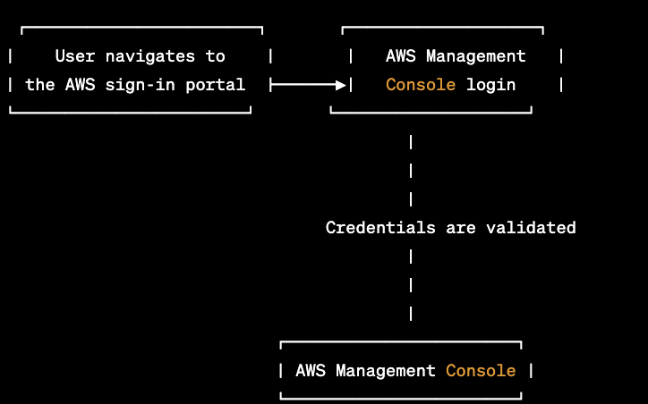

**S3 Bucket Creation:**

After logging into the AWS Console, the user clicks on the "S3" option, which directs them to the S3 page where they must click on "create bucket". Then, the user is asked to provide the necessary information such as the bucket name, location, owner, permissions, versioning, logging, replication, events, website hosting, encryption, and tags. After specifying the bucket properties, the bucket can be created and is ready to receive data.

**Figure 10** UML Graph for S3 Bucket Creation

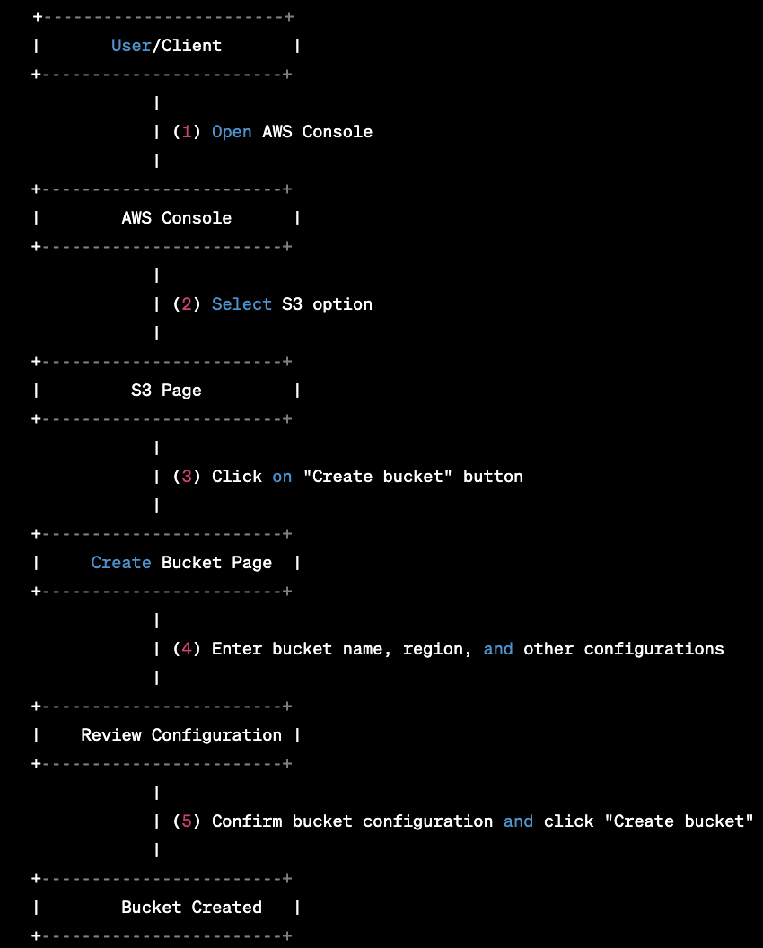

**AWS Glue ETL Job:**

Users logged into the AWS console can create a Glue ETL job by specifying the task's name, kind, data source, and data destination. Additionally, the user can define connections, security setups, and task parameters. Once the job is created, it can be executed either on demand or according to a schedule

**Figure 11** UML Graph for ETL Job

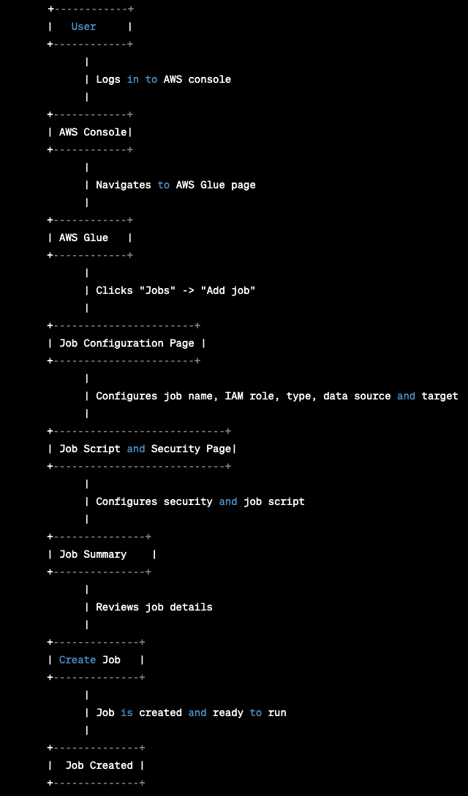

**Crawler**

Crawler is used to successfully take the data from S3 bucket into AWS Glue, where the ETL job can be performed. After creating AWS Glue task, one can create a crawler by giving the necessary information such as the database name, and IAM role. After the successful execution of crawler a table schema and metadata should reflect in the Glue Crawler information page.

**Figure 12** UML Graph for Crawler

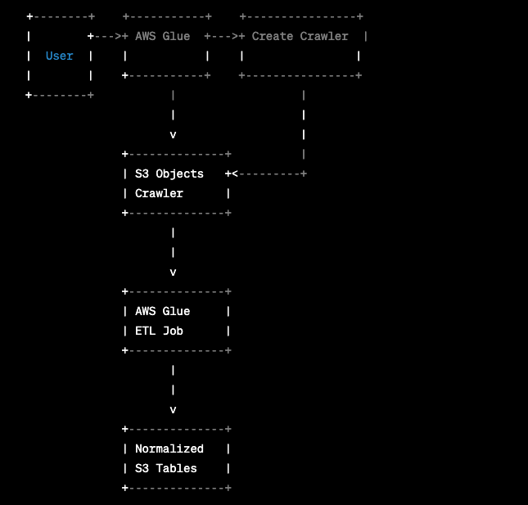

**Redshift:**

Navigate to the Redshift page and select "create cluster" after signing into the AWS Management Console. Provide the necessary settings and configuration for the cluster as required. Review the configuration, then click the confirm button. The cluster building process often requires some time.

**Figure 13** UML Graph for Redshift

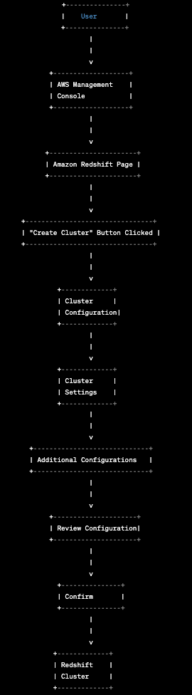

**S3 Bucket Replication:**

To offer reliability of data availability, S3 replicas can be created across regions. The creation of S3 bucket replicas require user to specify the configuration for replication such as region. The Figure 14 below shows the UML Graph for creation replicas of S3 buckets.

**Figure 14** UML Graph for S3 Bucket Replication

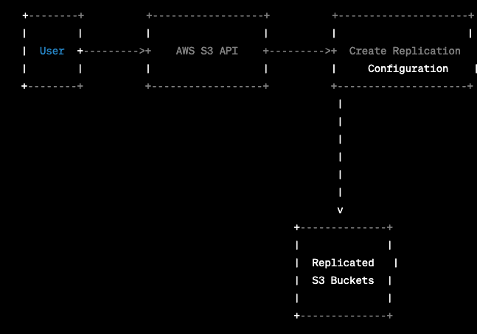

**Glacier:**

To create an S3 Glacier vault, first the user must log in to the AWS Console and choose the S3 Glacier service option. Then the region of vault has to be specified. The user enters the required information, including the vault name, vault access policy and vault notifications. After reviewing the information, the user confirms the vault's creation by clicking "Create Vault."

**Figure 15** UML Graph for S3 Glacier

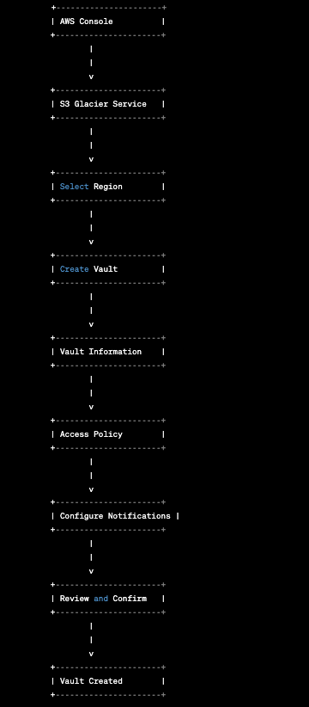

**3.6. Context and interface requirements**

The user interface for this project was developed in the VS Code IDE using HTML, CSS, and JavaScript. Users can easily log in to the application using Google authentication as Firebase was integrated as the database to store and retrieve user credentials. Test users were also created specifically for testing purposes. The testing environment included multiple web browsers such as Apple Safari, Mozilla Firefox, and Google Chrome.

GitHub and Firebase were both used for deployment. The web application was released using the Firebase hosting service, and version control was handled via GitHub. In terms of system interface requirements, the user interface was created to be simple to use, with quick navigation and distinct function labels. The user interface's preliminary design is shown in Table 4 below.

**Table 4** Functional Description of UI Design

| **Functionality** | **Description** |
| --- | --- |
| Login | Users can log in to the application using their Google credentials or Registered Credentials. |
| Sign up | Users can create a new account using their email and password. |
| Data Analysis & Visualization | Users can view the final results on Tableau Dashboard |
| Dataset Access | Users can access the S3 bucket and download the Datasets used in this project. |

**3.7. Technology and resource requirements**

Programming technologies leveraged in this project includes Pyspark data preprocessing and exploratory data analytics, Python for reporting analytics to generate statistics for the theory of the paper, Javascript to build the functional components of the User Portal, HTML Scripting for adding design to the user portal, and NodeJS to handle the scripting for deployment.

Technology tools used in this project includes “Google Drive, S3, S3 Glacier, and Redshift” for data storage, and data warehousing, “Google Colaboratory Pro” for EDA and data pre processing of the raw data with PySpark backend, “AWS Glue” for ETL and creation of normalized data tables, and “Tableau” for visualization and analytics.

**Chapter 4. System Design**

**4.1 System architecture design**

The architecture diagram that explains the data flow of the big data analytics platform is provided in Figure 16. The data is downloaded from sources NOAA, FEMA, and uploaded to Google Drive. This dataset is of size 44 GB. The data is pre-processed with the PySpark tool and the cleaned dataset is stored back to Google Drive. The reduced size of the dataset is 5 GB. This dataset is then synced to AWS S3 programmatically with AWS Boto3 module, and Google Drive API. The cleaned data is replicated to S3 buckets in multiple regions to offer reliability and availability of data at all times. Further, the S3 bucket is also archived on S3 glacier to save snapshots that can be accessed in the future in event of failure. The cleaned datasets on S3 buckets are loaded on to AWS GLUE with crawlers to perform ETL and create normalized data tables in relational schema. The design of this relational data model is provided in Figure 17 and discussed in section 4.2. The normalized tables are loaded on to AWS Redshift. The AWS Redshift is allowed to receive inbound requests from specific IP addresses for Tableau connection and analytics. Furthermore, a web portal is developed with SSO using Google Firebase. Note that all the AWS resources in the system are only accessible for users with SSO, and MFA access for additional security.

**4.2 System data and database/ data warehouse design**

The relational data model of the data tables loaded in the AWS Redshift is provided in Figure 17. The date and county tables are independent entities, while flood_events and weather_stations are related to county through a foreign key. Both flood_events and weather tables are related to the date table through a composite foreign key.

**Figure 16** System Architecture Diagram

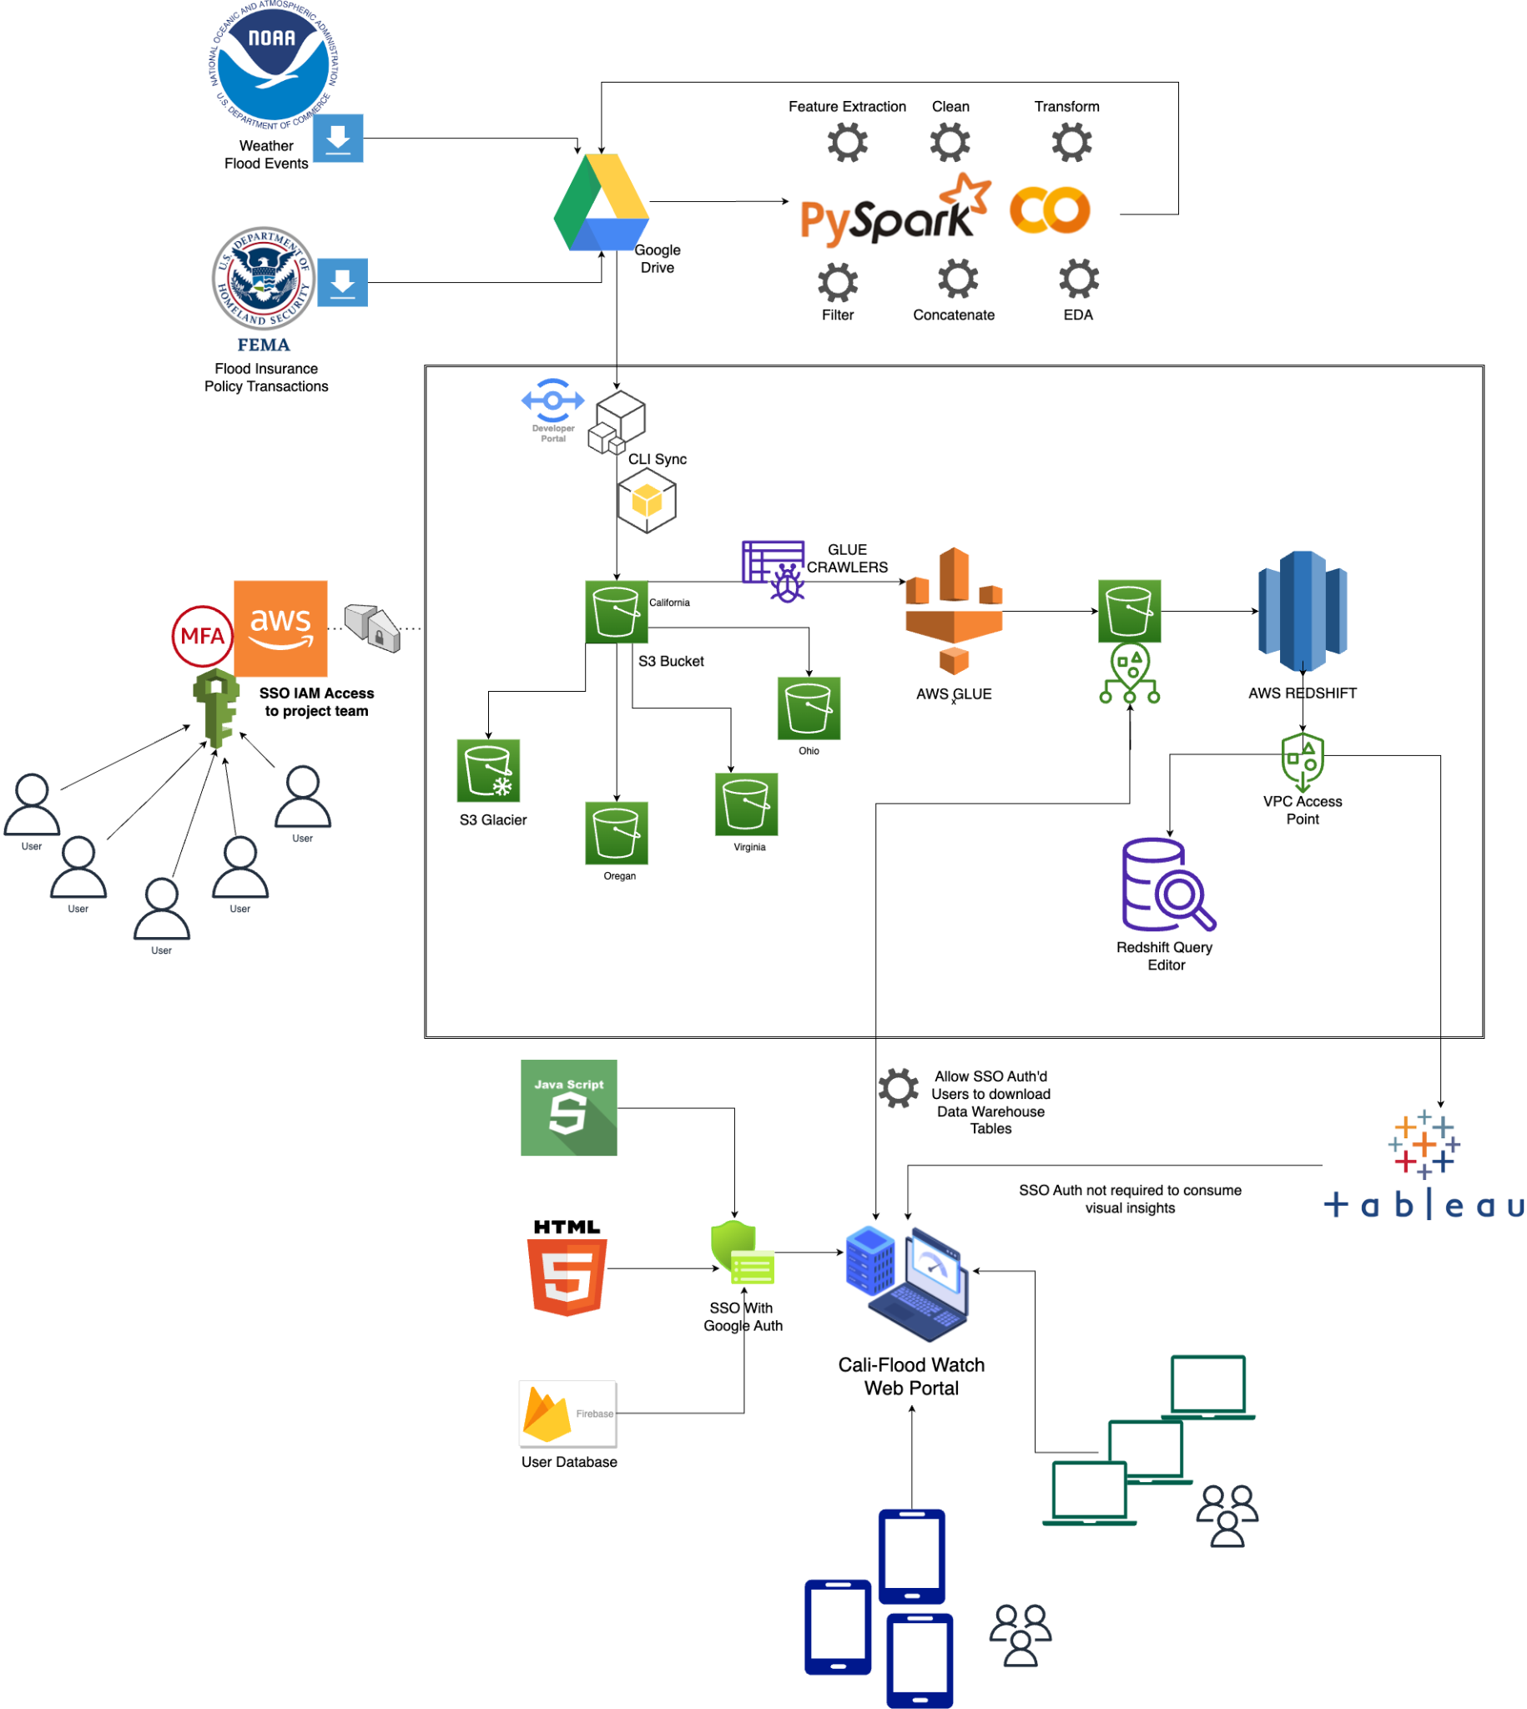

The table ca_county_yearly_insurance_stats is related to the county table through a foreign key, and the county_daily_flood_weather table is related to the county and date tables through foreign keys. The county_daily_flood_weather table also contains information from the weather table and flood_events table. The tables are connected through foreign keys, which enable data to be linked across multiple tables for more efficient querying and data analysis.

**Figure 17** Relational Data Model Design

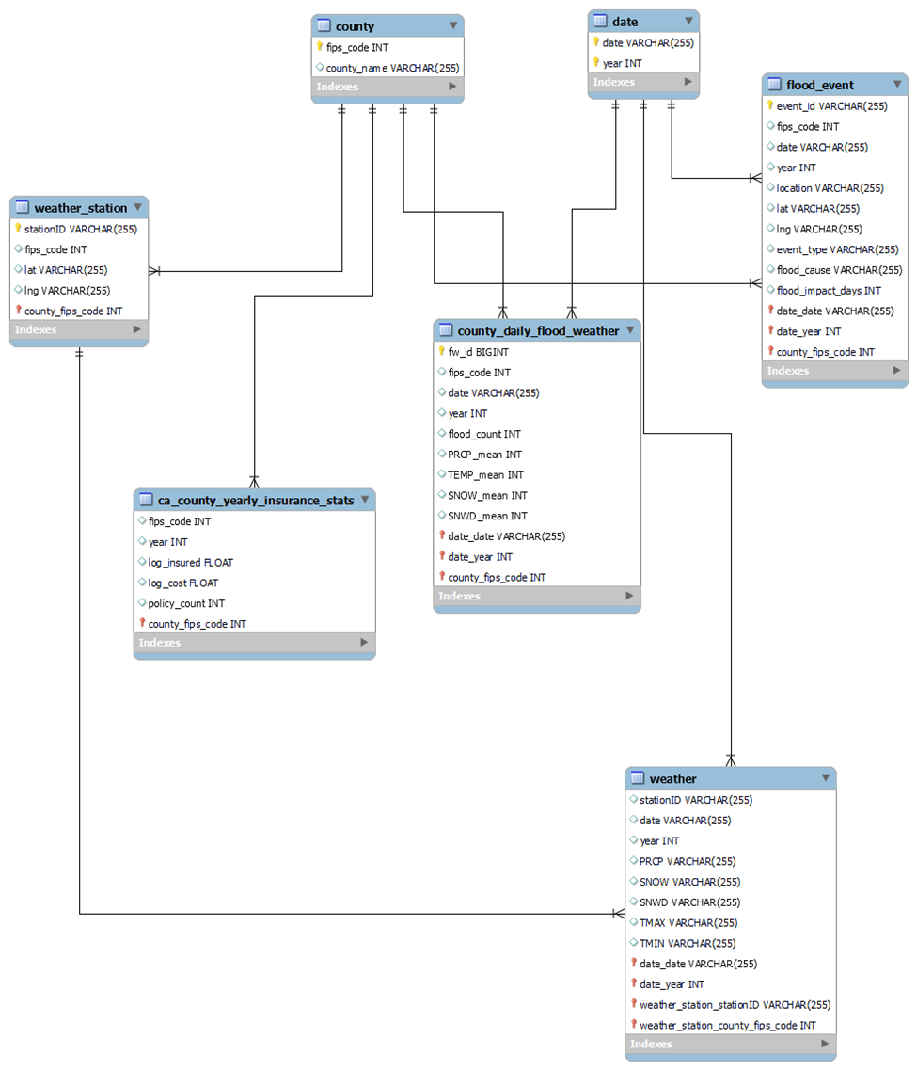

**4.3 System interface and connectivity design**

The system interface and connectivity design for the Baywatch project includes several external interfaces to third-party systems/components. Google Firebase authentication is used to authenticate users and store their credentials in the Firebase real-time database, while an Amazon S3 Bucket connection is established to retrieve data and display it on the website. Tableau is used as an external connection to populate plots on the Baywatch website. The system user interface is developed using HTML, CSS, and JavaScript, while Node.js is used as a local host server to run the website and manage incoming requests. The developed connectivity protocols include HTTPS for communication between the website and the external APIs, REST API to retrieve and update data from the Firebase real-time database, and JSON for data exchange between the website, Firebase, and Tableau APIs. These interfaces and protocols provide seamless communication between the Baywatch website and the external systems, ensuring smooth functioning of the overall system. The interface connectivity design is shown in Figure 18.

**Figure 18** Interface Connectivity Design

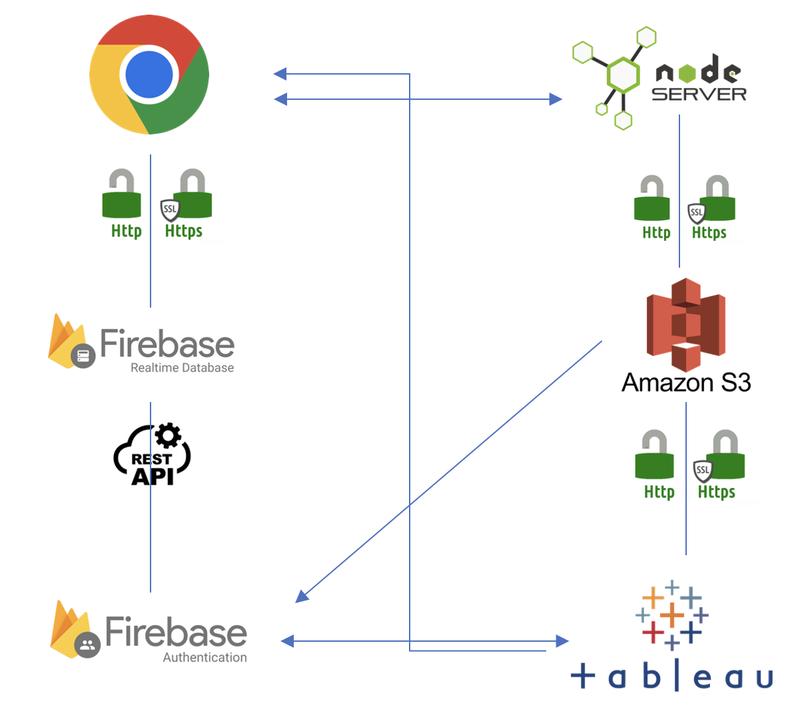

**4.4 System user interface design (for software project only)**

The Tableau dashboard can be accessed by clicking the "View Dashboard for Free" button on the index page, which is available to all users. The index page is shown in Figure 19 below. Additionally, registered users have SSO access to download the S3 bucket data through a shortcut button on the bottom of the page. To access the Data tables, users must first log in or sign up with Google SSO on the website. Figure 20 shows the SSO page for the portal.

**Figure 19** Index Page of Big Data Baywatch Platform.

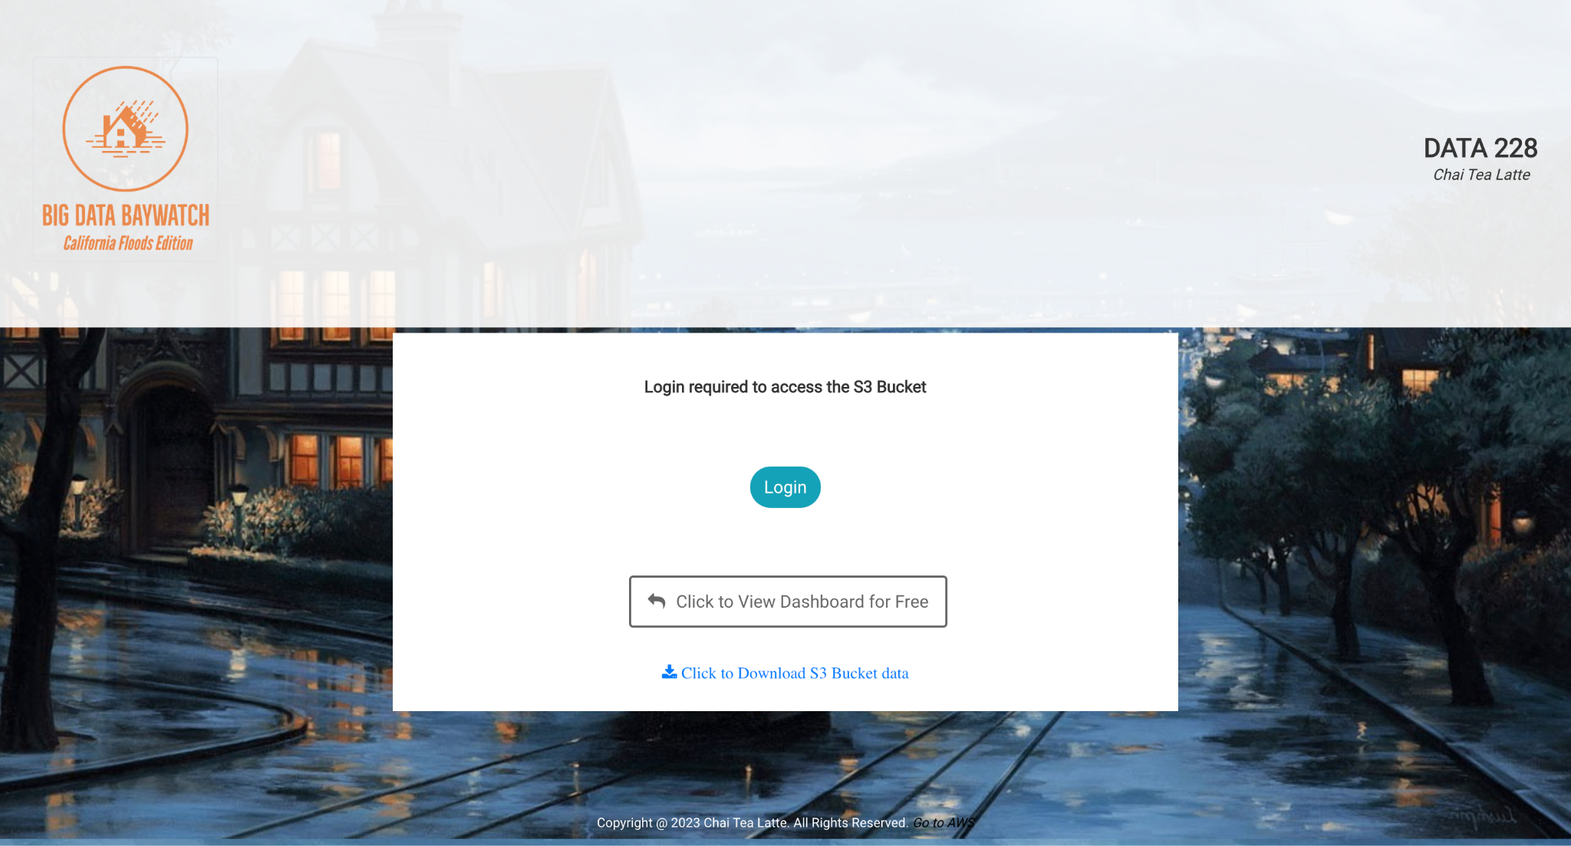

**Figure 20** Google SSO Page of Big Data Baywatch Platform.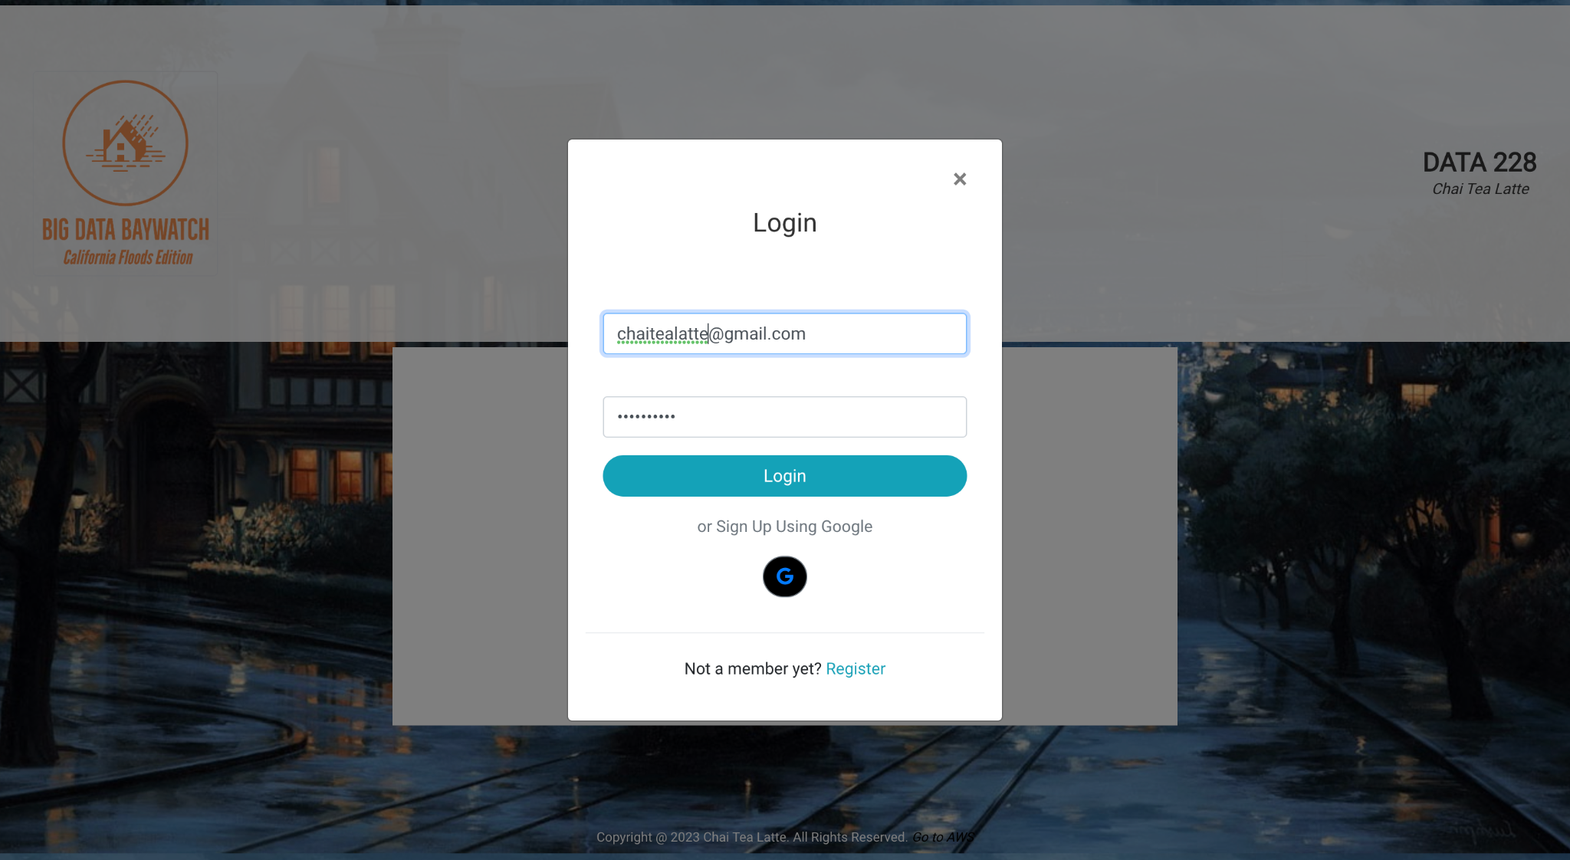

​User details are stored in the Firebase database under the authentication tab, with unique IDs assigned to each user to ensure privacy and prevent duplication. Refer Snapshot provided in Figure 21 below. The user SSO Authentication is enabled in two forms (a) Email/Password, abd (b) Google Sign In Authentication. Refer Figure 22 below for the two SSO methods approved in Firebase Authentication.

**Figure 21** Snapshot of Firebase Authenticate Users

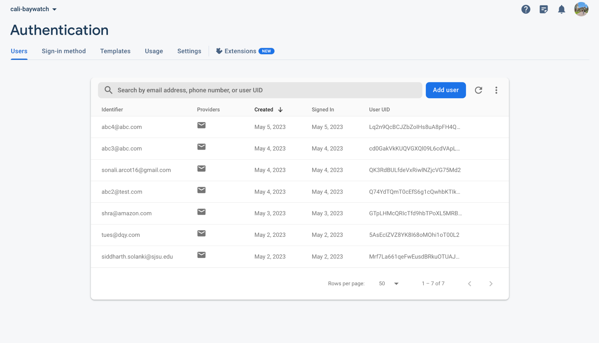

**Figure 22** SSO Methods

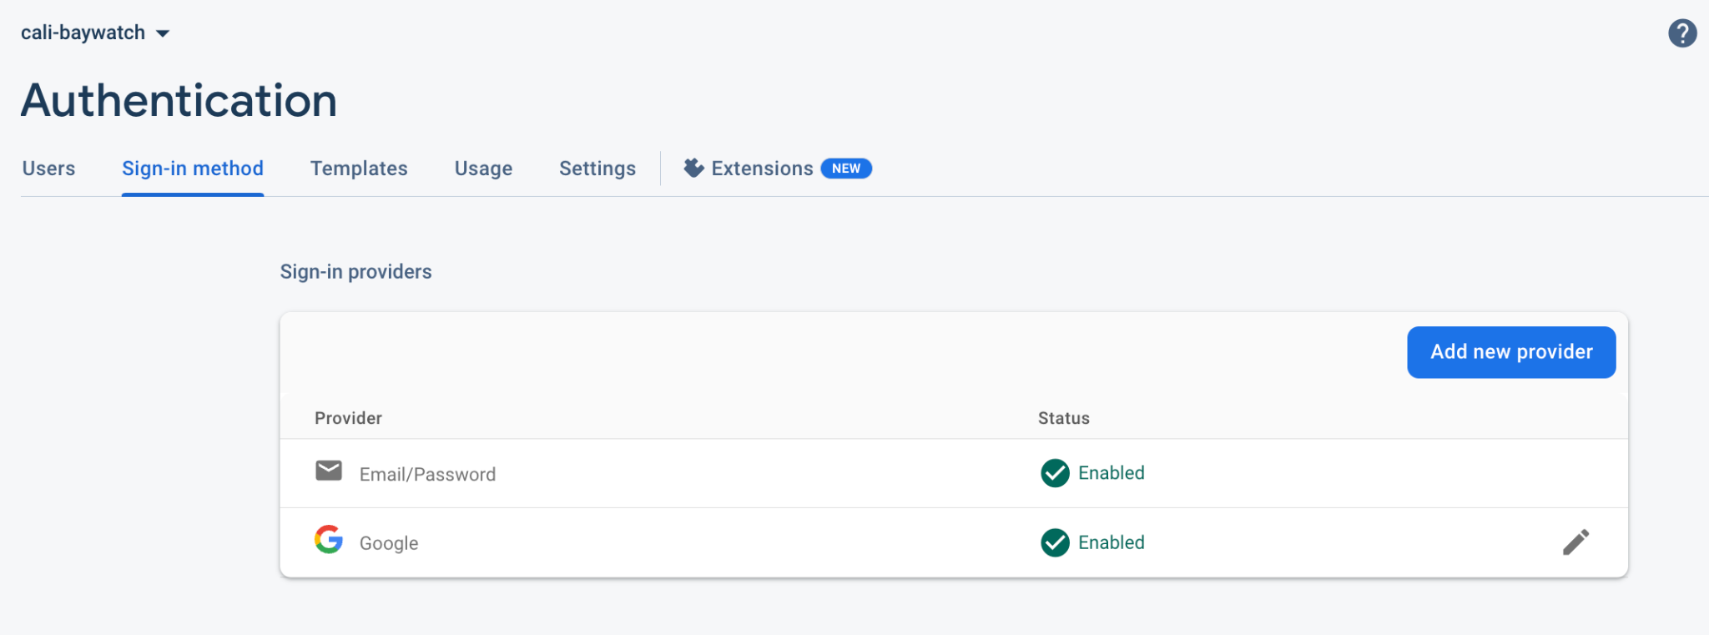

Upon successful SSO verification, the users get access to download the data tables from AWS S3 as shown below in Figure 23. The AWS S3 bucket allows inbound requests only from this web page which is protected with SSO security.

**Figure 23** Authenticated User’s Page to Access the Data Tables

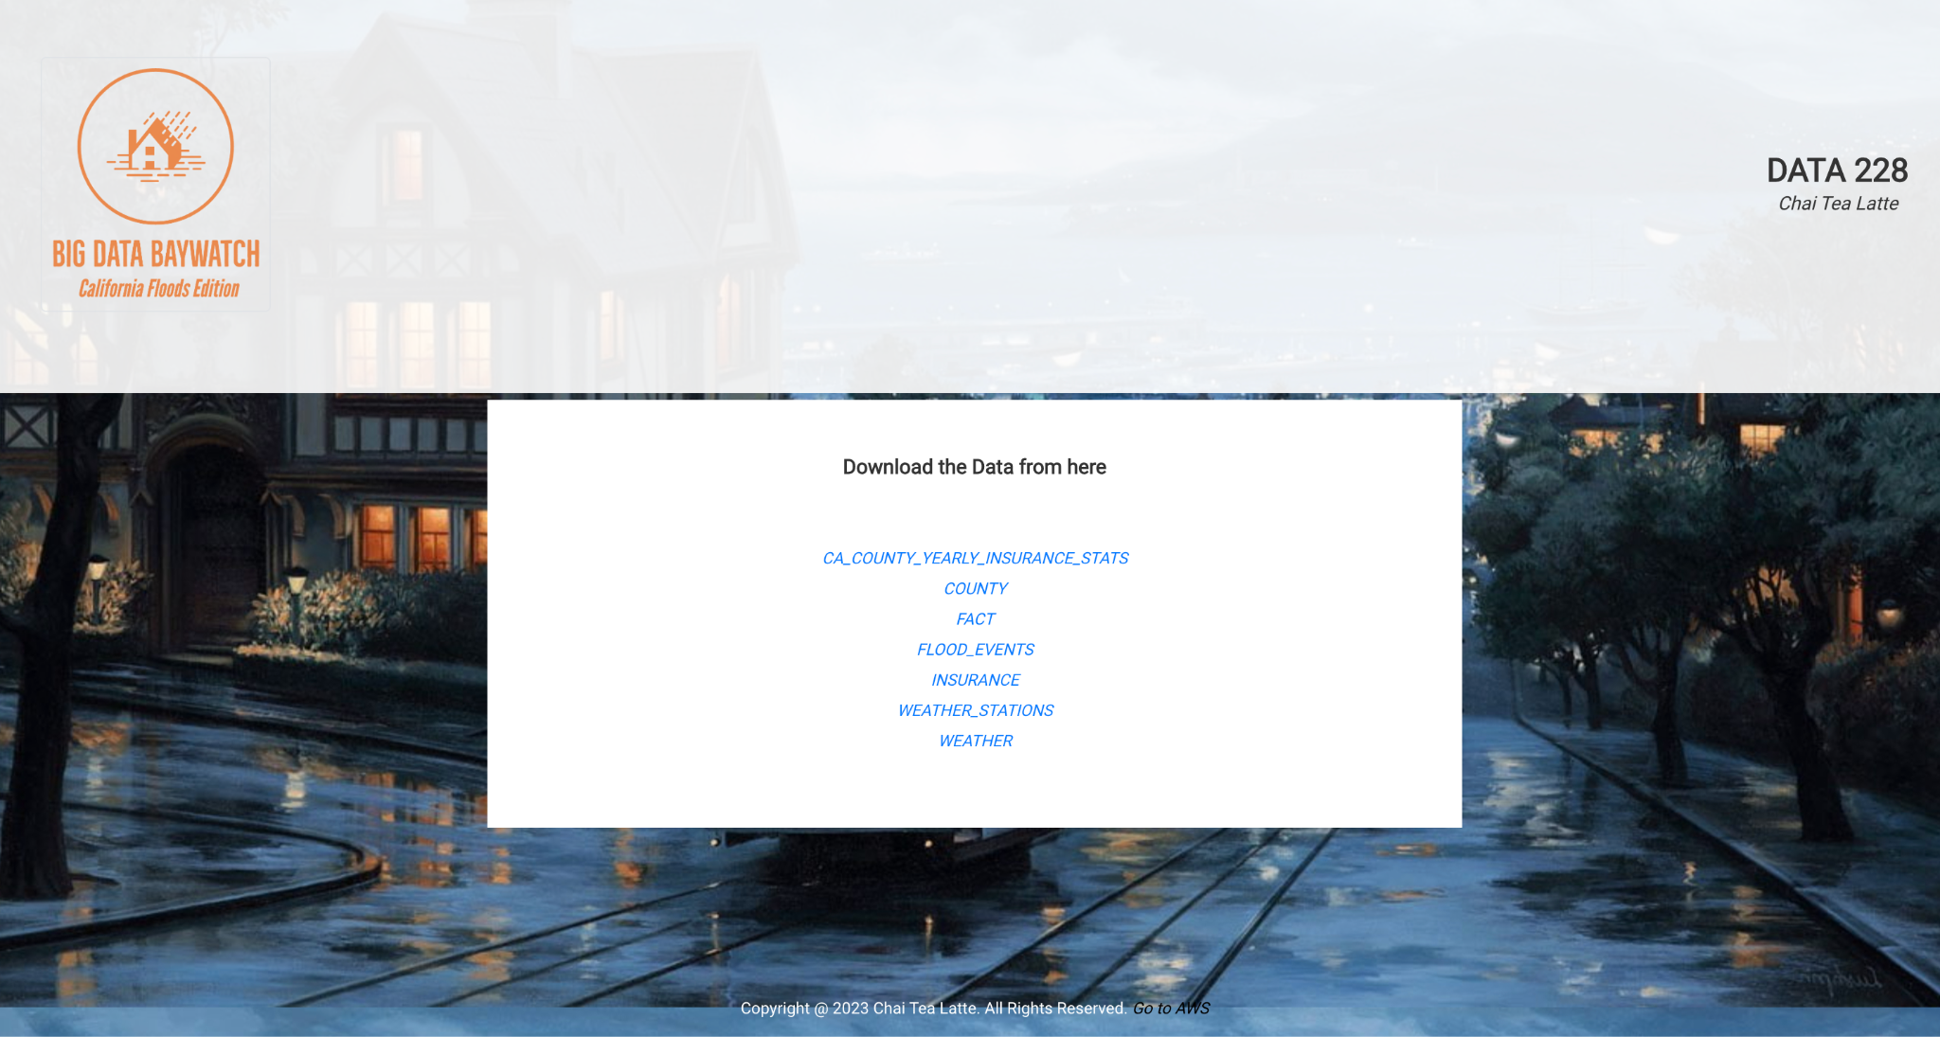

**4.5 System component API and logic design**

There are multiple API components used in the system. Firstly, Google Drive API and Amazon S3 API are used to sync tables from Google Drive to S3. Secondly, APIs are used for replication of S3 buckets across regions as demonstrated in Figure 14. Finally, Redshift API connector is used to connect Redshift server to Tableau for creating visualizations. There are no specifically APIs designed for the purpose of this project. Rather, existing APIs have been leveraged to implement the Big Data Analytics solution. The testing of APIs is documented in detail in Section 6 of this report.

**4.6 Design problems, solutions, and patterns**

There are several design problems that we faced mostly due to the non-availability of free access to the resources. Firstly, the free tier limitations of AWS S3 made us pivot and choose Google Drive and Google Colaboratory Pro for storing the raw datasets and performing the initial data preprocessing steps. Secondly, the non-availability of free-access to Zapier 3rd party API to sync Google Drive and AWS S3 made us to implement it programatically. Finally, the lack of knowledge of web development technologies made us to choose the readily available Google Firebase for implementing the SSO and deployment of the web portal. In sum, the design problems were encountered and alternative solutions were considered for smooth execution. Finally, if we were to redo the project at scale, and have no financial constraints we would choose AWS S3 for the storage of raw datasets, AWS EC2, and SageMaker for data preprocessing, and finally, AWS Amplify to develop and deploy the website, and reduce our dependency on tools offered by Google, and be completely dependent on AWS solution stack. This allows for easy development and maintainability of the software product over time.

**Chapter 5. System Implementation**

**5.1. System implementation summary**

**Data Collection and Storage on Google Drive**

The datasets were downloaded from the portals NOAA, and FEMA directly by the download options provided. In the case of weather data, multiple files were downloaded, one per each year, and they had to be concatenated. All the files downloaded in its raw form amounted to a total of 45 GigaBytes and they were stored on Google Drive. Refer Figure 24, and Figure 25 for snapshots showing the datasets, and its associated file sizes all stored on the Google Dtive.

**Figure 24** Snapshot of Flood Events, and Flood Insurance Datasets with File Sizes

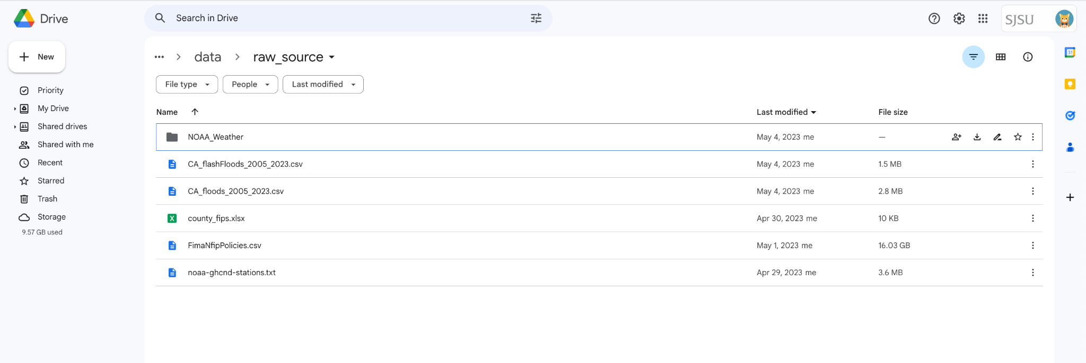

**Figure 25** Snapshot of Weathe Data Sets per Year with File Sizes

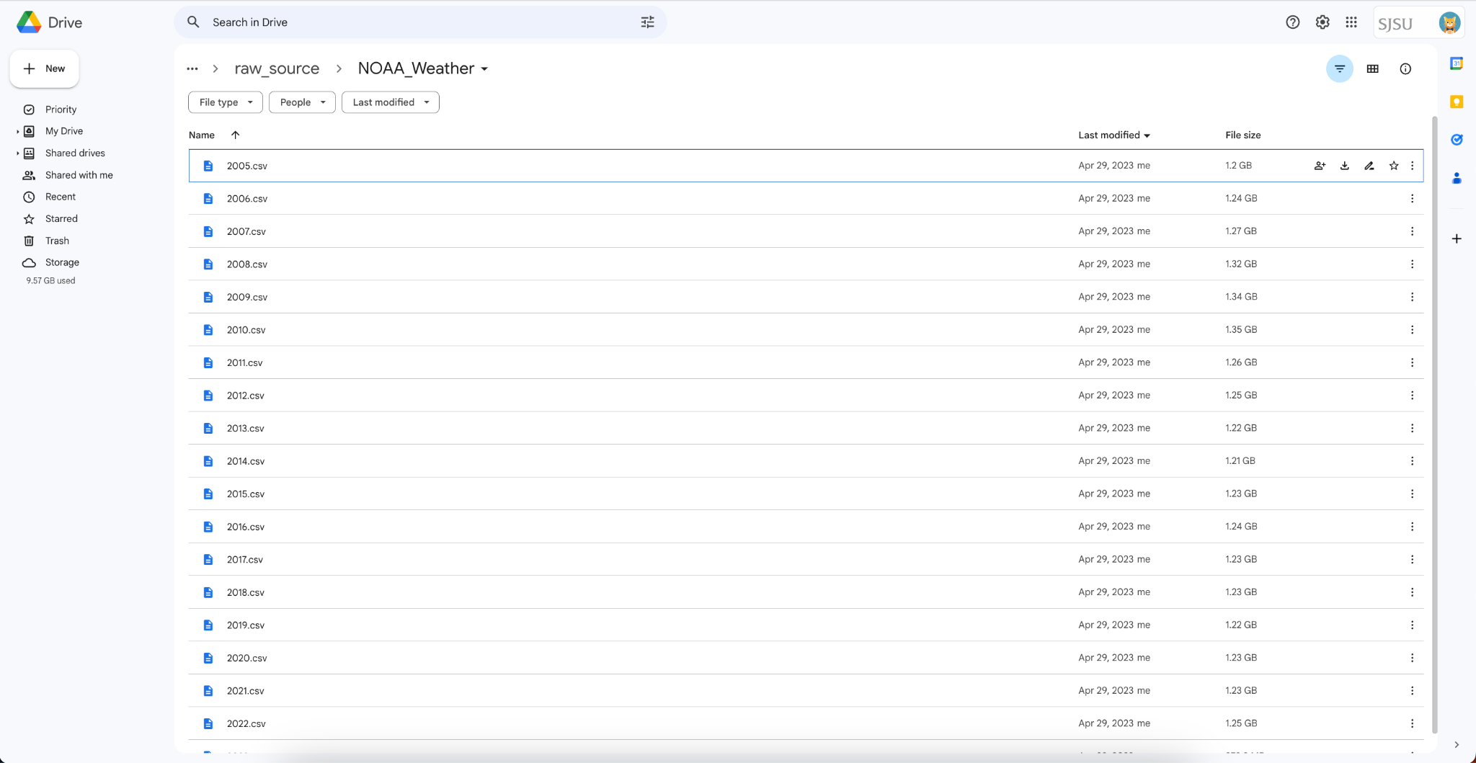

**Single Sign On (SSO) and Multi Factor Authentication (MFA)**

The resources on AWS are protected with SSO and MFA access to all the developers of the project. Refer Figure 26, showing the MFA mode for all the SSO authenticated users of the project. In Figure 27, a snapshot of the MFA from the DUO Software is provided.

**Figure 26** AWS IAM Page Displaying SSO MFA Access Authenticated Users 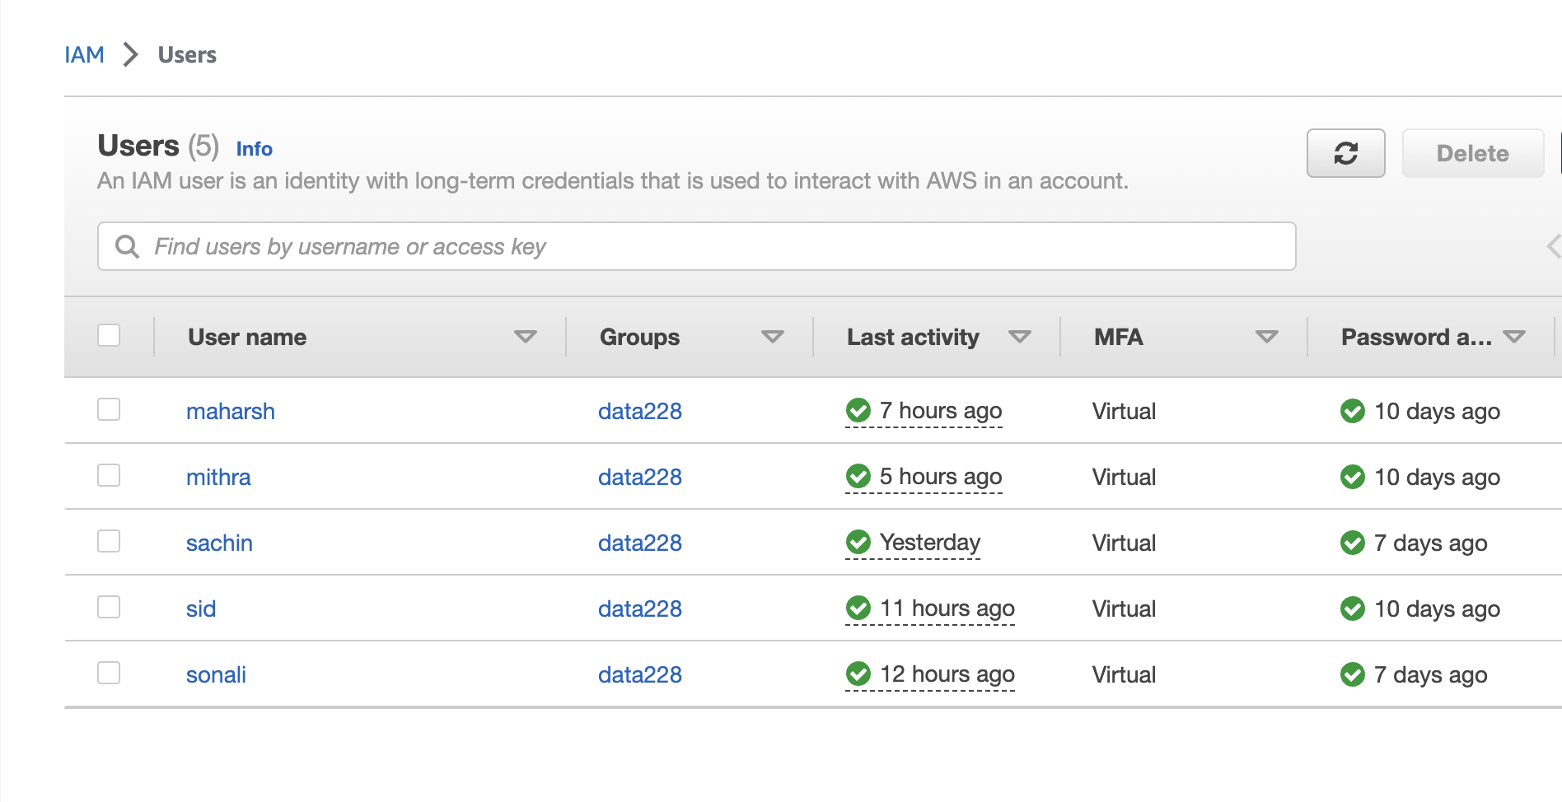

**Figure 27**

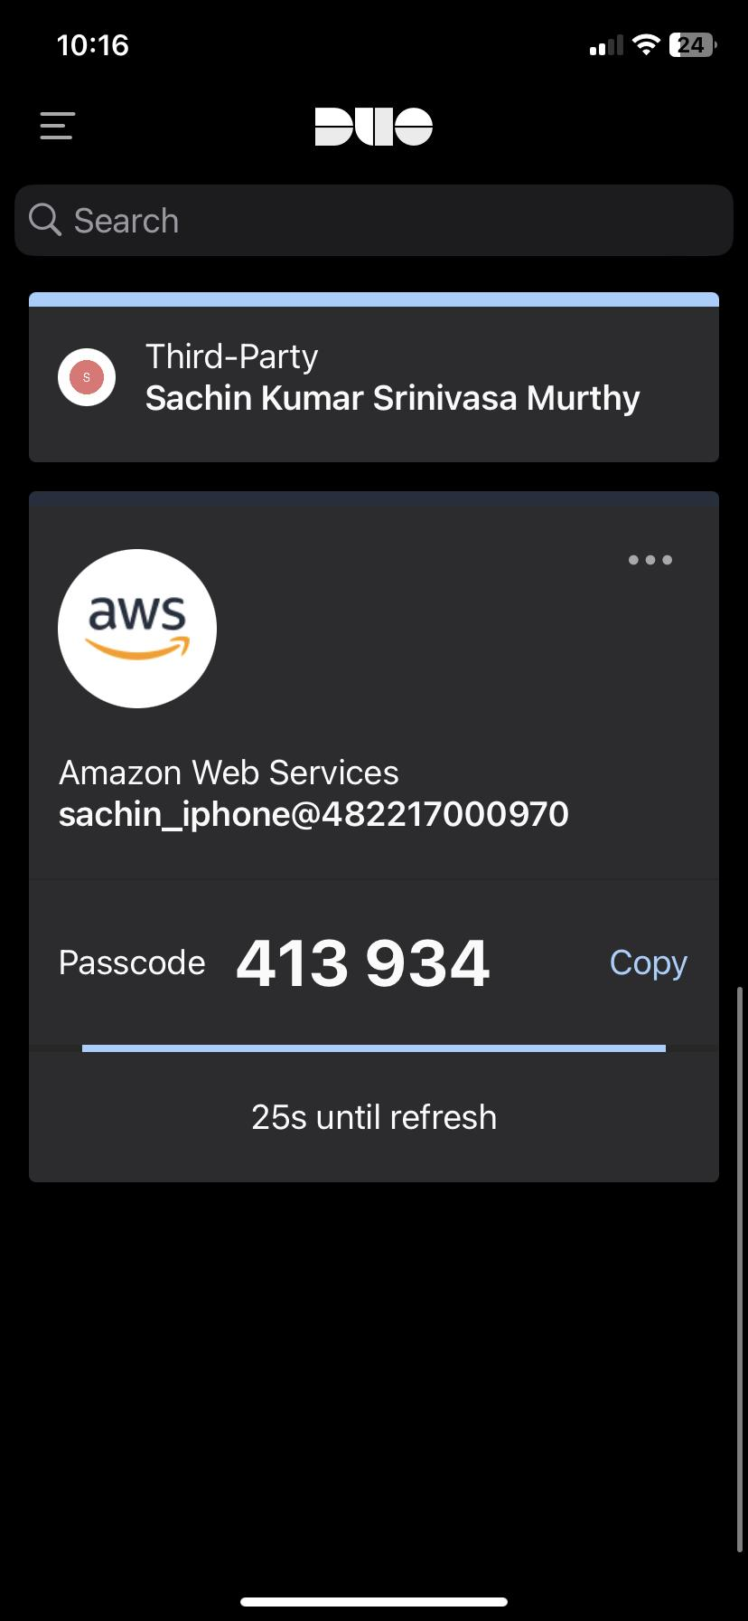

**Data Cleaning with Google Colaboratory, and Pyspark Backend**

As shown in the Figure 16 of Section 4, there are six types of data pre processing steps done with PySpark on the Google Colaboratory. These steps include Filtering the weather data for California region, concatenate all the year-level files, perform EDA, transform the data tables i.e., pivot operations, data cleaning, and feature extraction. The code files for these processes are documented in three IPYNB files on the github repository of the project [7].

**Create S3 Bucket:**

The initial step in the AWS project is to create an S3 bucket where the data will be stored. For our project purpose the bucket is named as “**data228**”, refer Figure 28 and Figure 29. Inside the S3 bucket, two folders named Input and Output are created. The Input folder contains the input data that will be passed to AWS Glue. Here is where the weather, flood and insurance data will be uploaded. Via Programmatic Access Sync the uplod is faster as compared to Console Access Sync. We tested Console Access Uploading, and all the three pre-processed data tables took approximately 45 min to finish uploading on to the S3 Bucket. The Output folder will be used in the subsequent stages of the project to transfer the data from Glue to the S3 Bucket.

**Figure 28** The Created Buckets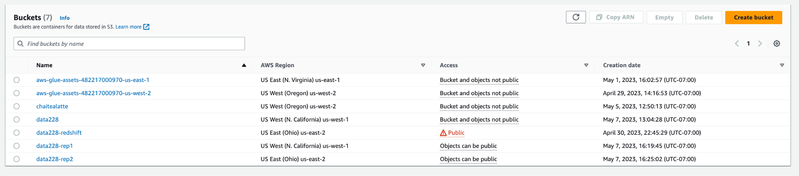

**Figure 29** Bucket Creation Process

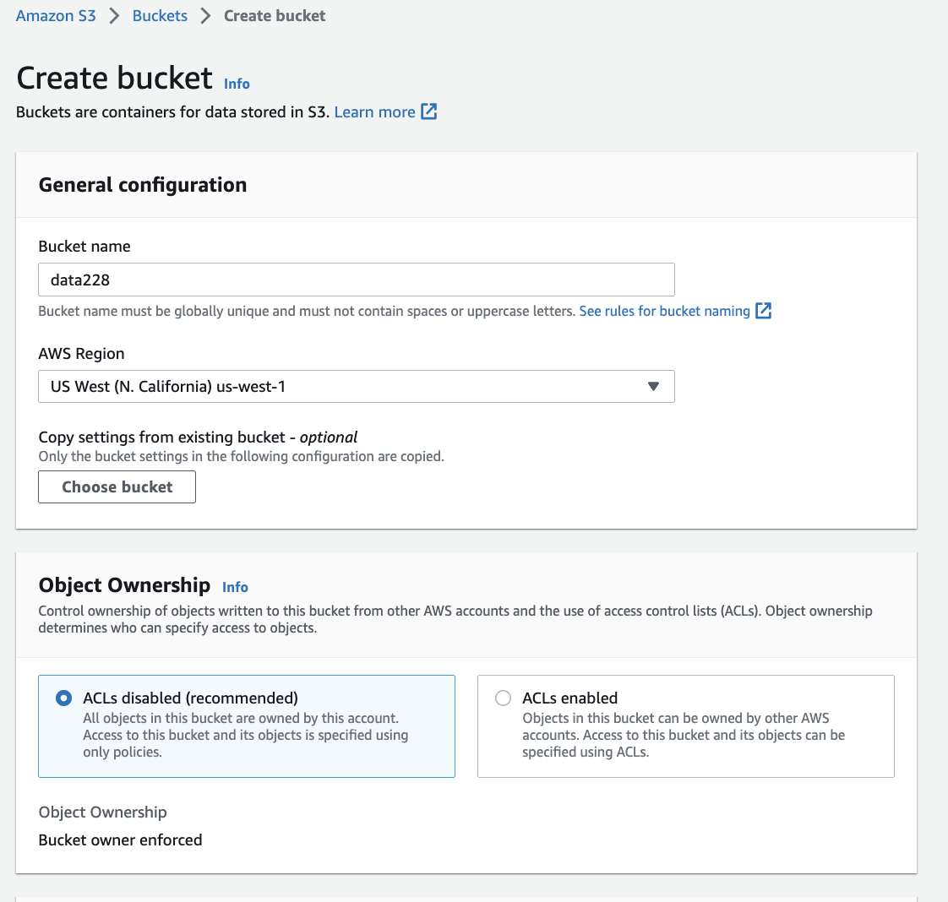

**AWS Replication:**

Implementing AWS S3 buckets with multiregion replication in our project will considerably increase data accessibility and retrieval performance by offering different endpoints for accessing datasets. The datasets in parent bucket are prepped and moved into a new folder for replication, and replication buckets in a different region are created for redundancy. Replication rules are then set up to ensure that objects in the parent S3 bucket are replicated in both the original and new region buckets. Refer Figure 30, and Figure 31.

**Figure 30** The "data-228" S3 bucket is used for replication purposes

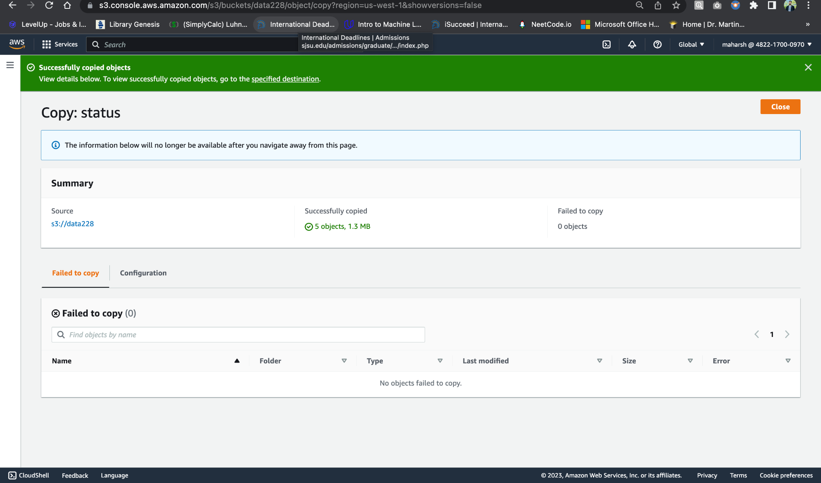

**Figure 31** A replication bucket was created to store the raw datasets for the US-West-1 region.

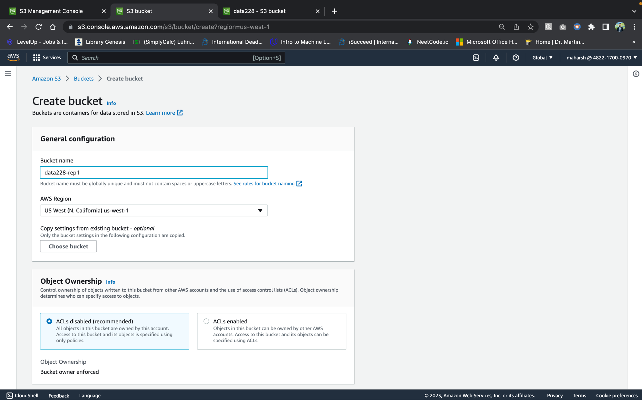

Another bucket, named "data228-rep2", was created to hold the S3 replication for a different region to improve data access and retrieval performance by providing multiple endpoints for accessing flood-related data, Refer Figure 32. The region chosen for this bucket was US-East-2.

**Figure 32** Creating another replication bucket



A replication rule was created for the parent S3 bucket, "data228", which replicated the objects in "data228-rep1" that immediately copied all the objects as shown in Figure 33.

**Figure 33** Replication Rule

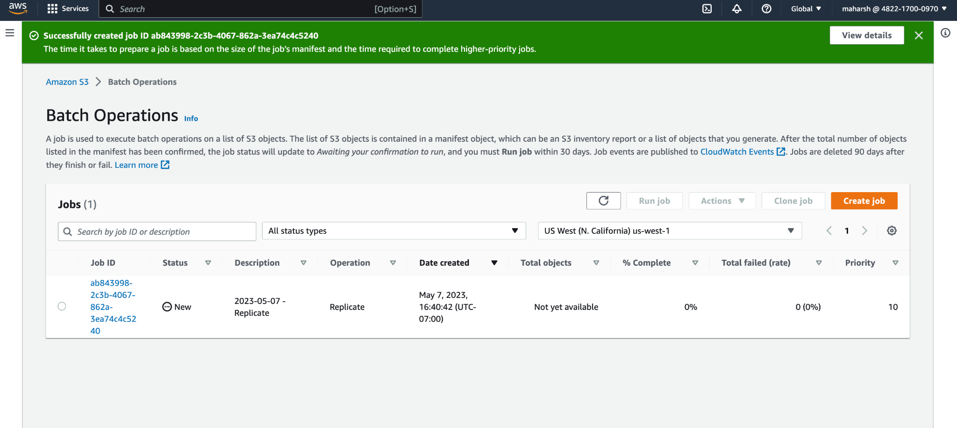

**Figure 34:** A new Bucket

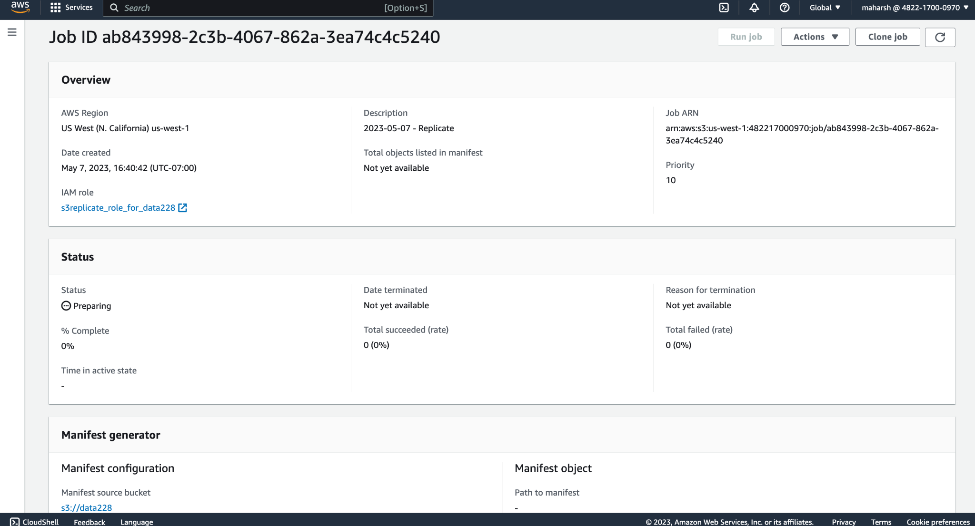

**Figure 35** A second Replication rule for parent bucket to enable cross-region replication.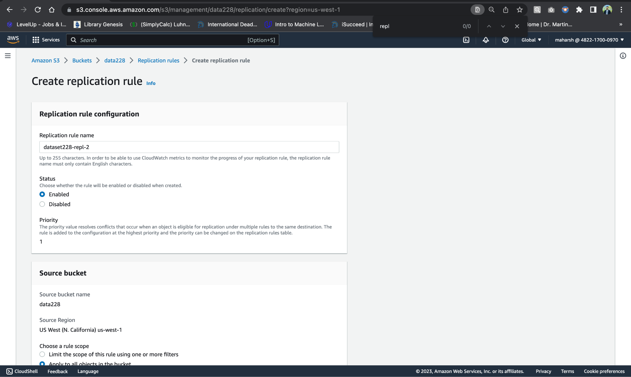

**Figure 36:** New Bucket made for Replication

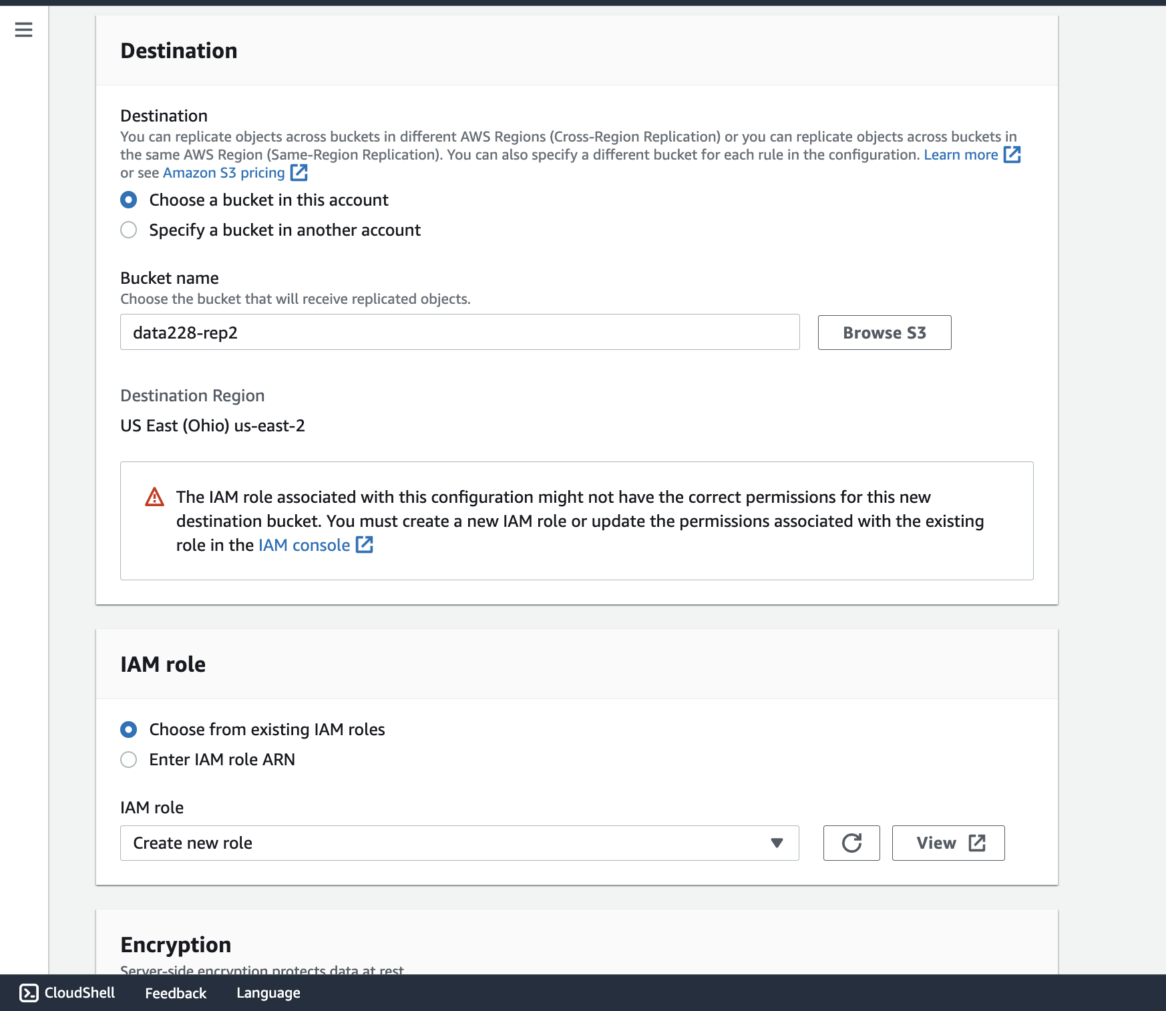

**S3 Glacier**

Amazon S3 Glacier is a cloud-based storage service designed for long-term backup and archiving of infrequently accessed data. It provides a low-cost storage solution that is also long-lasting, secure, and highly scalable. Businesses can use S3 Glacier to store large amounts of data that do not require frequent access while reducing storage costs. It also includes features like lifecycle policies and retrieval options to help users manage their archived data more effectively.

**S3 Glacier Vault Creation:** The first step in archiving data using S3 Glacier is to create a vault in the S3 Glacier service. This is where infrequently accessed data will be stored for backup and long term storage purposes. The process of creating a vault is straightforward and can be done through the AWS Management Console. Refer Figure 37.

**Figure 37:** S3 Glacier Vault for Archiving

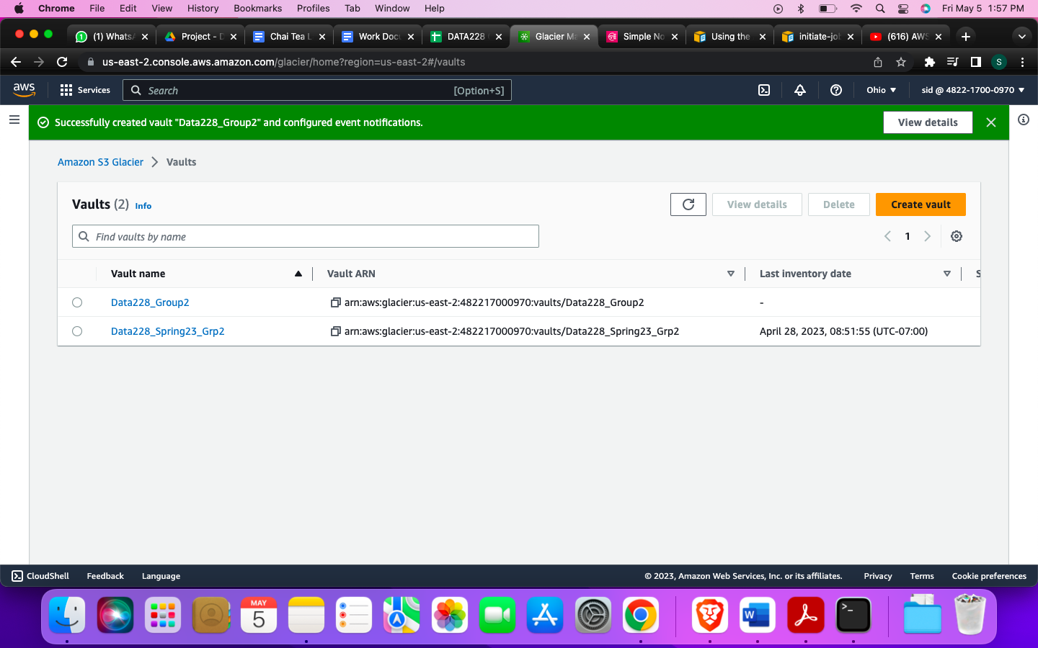

**Notification Service Setup:** As the process of uploading files onto S3 Glacier can take hours, it is important to have a notification system in place to notify us once the upload is complete. In this project, a simple notification service was set up and linked to our email ID. This ensured that we were promptly notified when the files were successfully uploaded. Refer Figure 38.

**Figure 38:** SNS setup for Glacier Vault updates

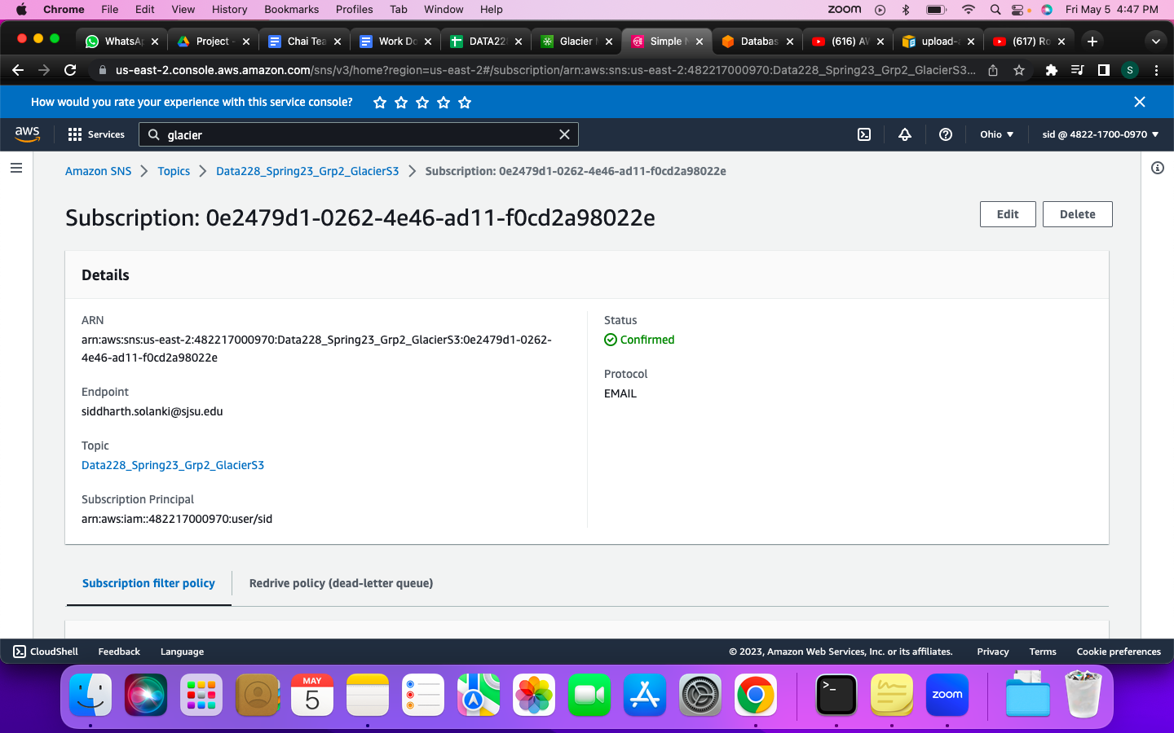

**Amazon CLI Setup:** To efficiently upload files onto S3 Glacier, Amazon CLI was utilized. Amazon CLI is a command-line interface that allows us to interact with various AWS services, including S3 Glacier. Using the CLI, we were able to run commands in their terminal to upload the required files onto S3 Glacier. This approach allowed for greater flexibility and efficiency in uploading the files. Refer Figure 39.

**Figure 39:** Amazon CLI for uploading files into Glacier

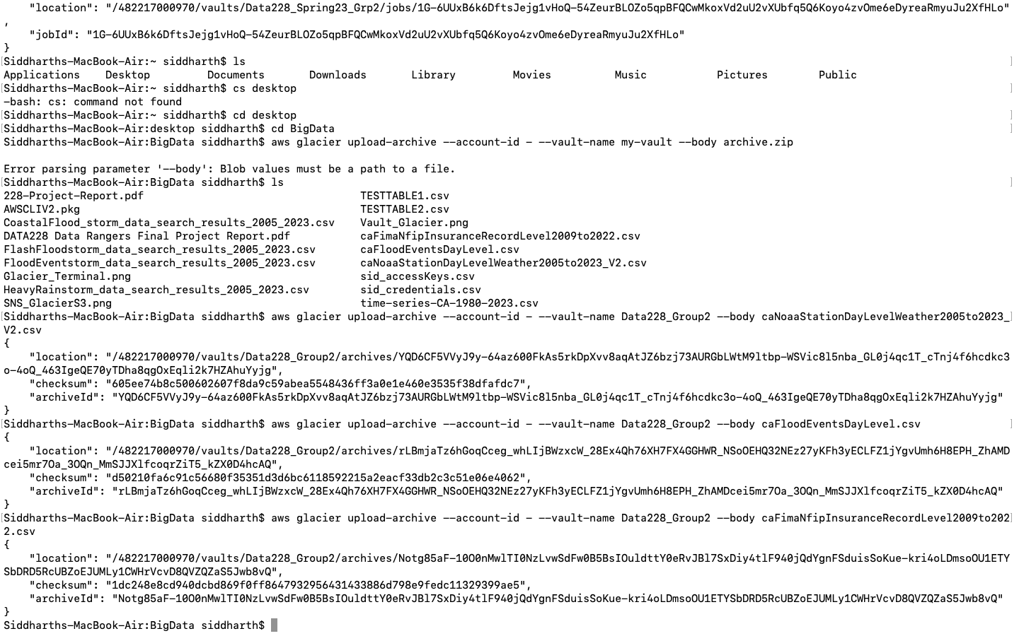

**File Upload and Notification:** After setting up the notification service and configuring Amazon CLI, we are able to successfully upload the required files onto S3 Glacier. Upon completion of the upload, we received a notification that the files had been successfully uploaded, and we were able to verify the same on the S3 Glacier Management Console. Refer Figure 40.

**Figure 40:** Notification received when uploading to Glacier is done

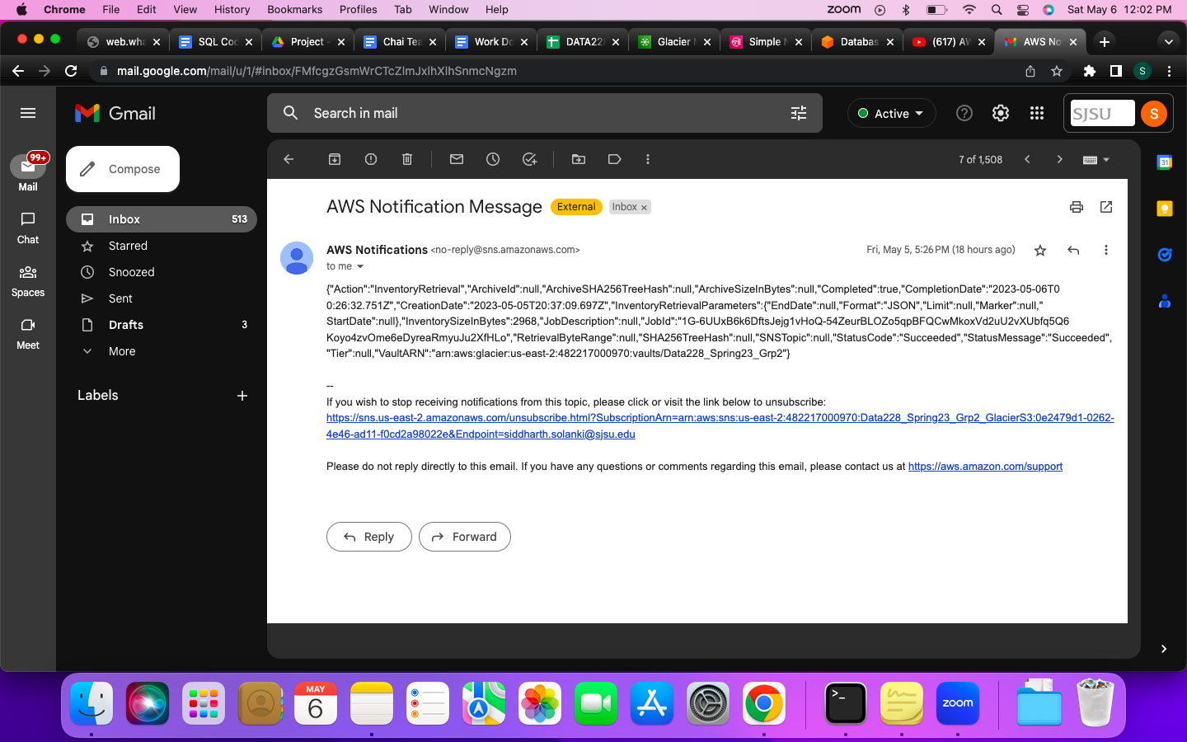

Archiving infrequently accessed data is an essential aspect of managing big data projects, and Amazon S3 Glacier is an excellent tool for this purpose. In this project, we successfully created an S3 Glacier vault, set up a notification service, and utilized Amazon CLI to upload files onto S3 Glacier. This approach ensured that the process of archiving data was cost-effective, efficient, and reliable.

**Glue Crawler:**

AWS Glue Crawler is a service that helps in automatically extracting schema and metadata data that has been stored in the S3 Bucket. A crawler “ChatTeaLatteCrawler” is Created as shown in Figure 41. In the process of creating the crawler, a database named “chai tea latte” and an IAM Role named “AWSGlueServiceRole-chaitealatte” are also created as shown in Figure 42 and Figure 43 respectively.

**Figure 41** Crawler Creation

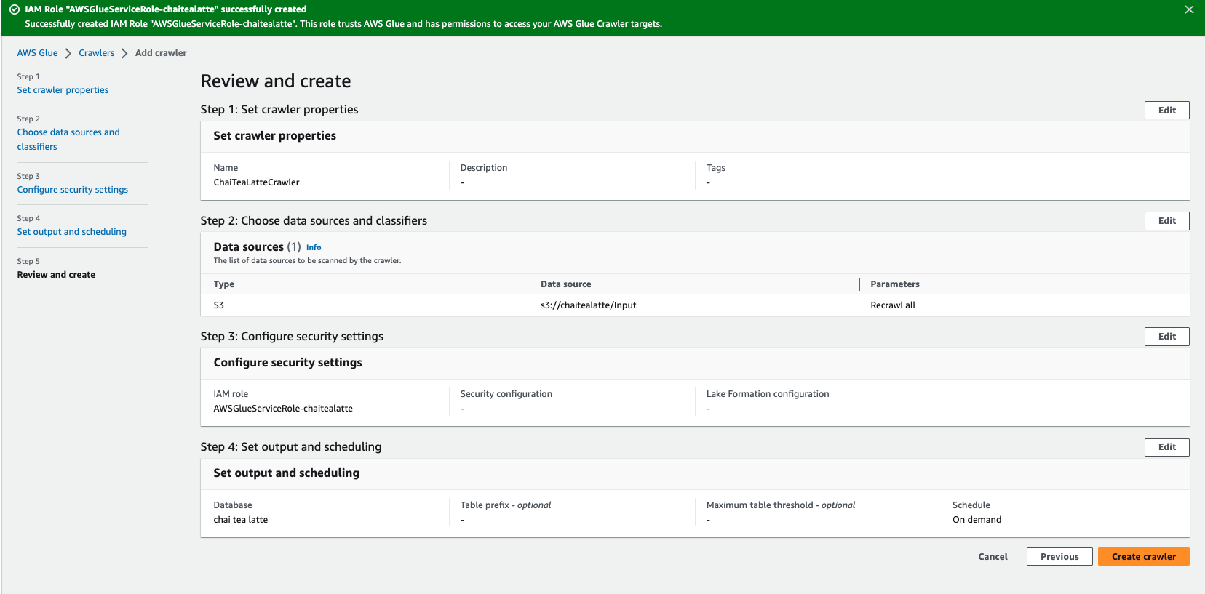

**Figure 42** Database Creation during Crawler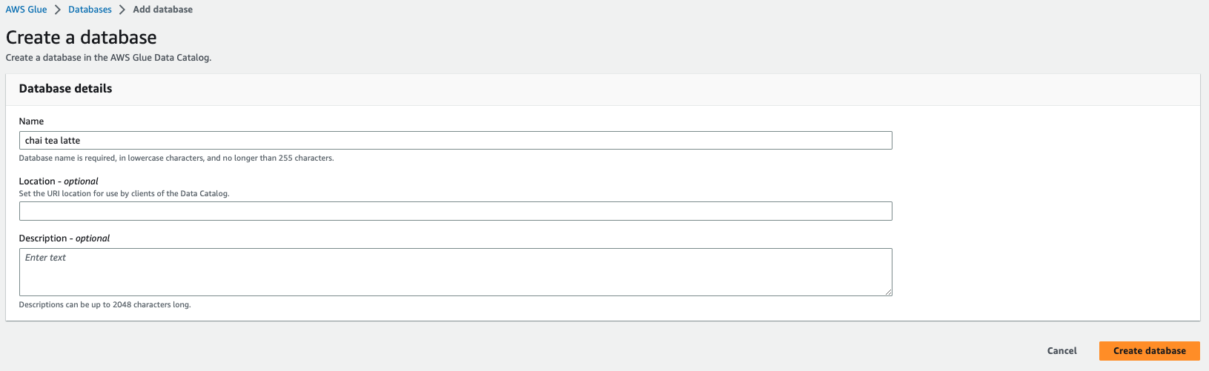

**Figure 43** IAM Role Creation: 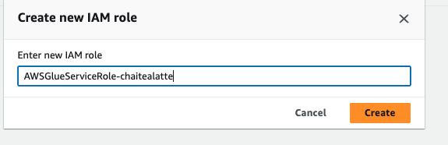

Once the necessary information, including the required database, IAM Role, and configuration, is provided, the crawler can be created. The created crawler must be run to crawl the data from the S3 bucket source along with the database and its schema to the AWS Glue crawler. The Figure 44 shows the three tables from S3 Bucket location: data228/Input that got crawled to the Glue.

**Figure 44** Successfully Created Crawler

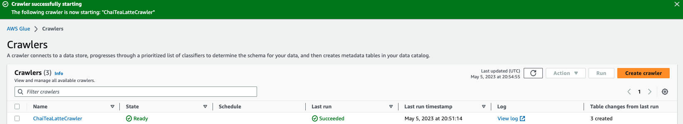

The next step after successfully crawling the data from S3 Bucket to Glue is to perform the ETL Job. For the purpose of the project we are performing the virtual ETL Job. where the source and target will be the S3 Bucket. The Below Figure and Figure explains the Virtual ETL job that was performed over the input data. All the three input tables- Weather, Insurance and Flood data were processed in the same ETL Job named “chai tea latte-v2” and the generated script is provided in the github[7] link. For the purpose of image visibility the snapshots of the job have been zoomed in and taken in three parts shown in the Figure 45 ,46 and 47 as shown below.

**Figure 45** ETL on Insurance data

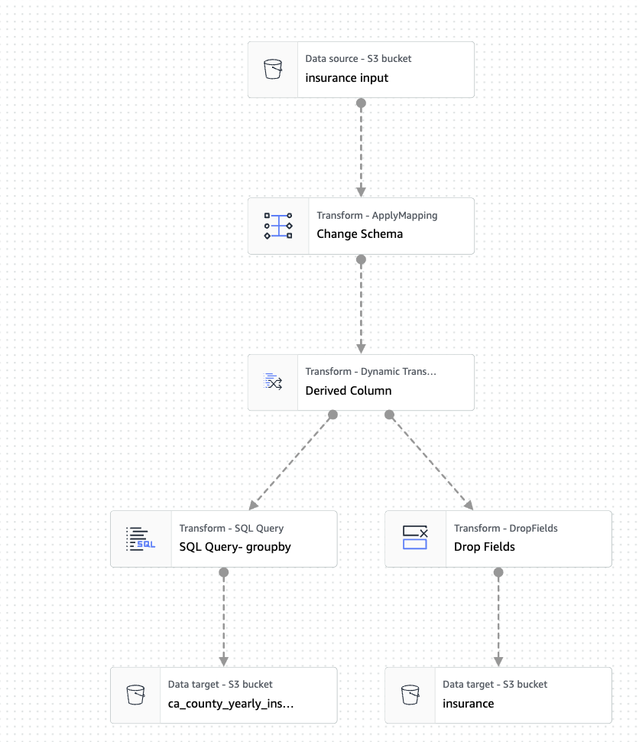

**Figure 46** ETL on Weather data

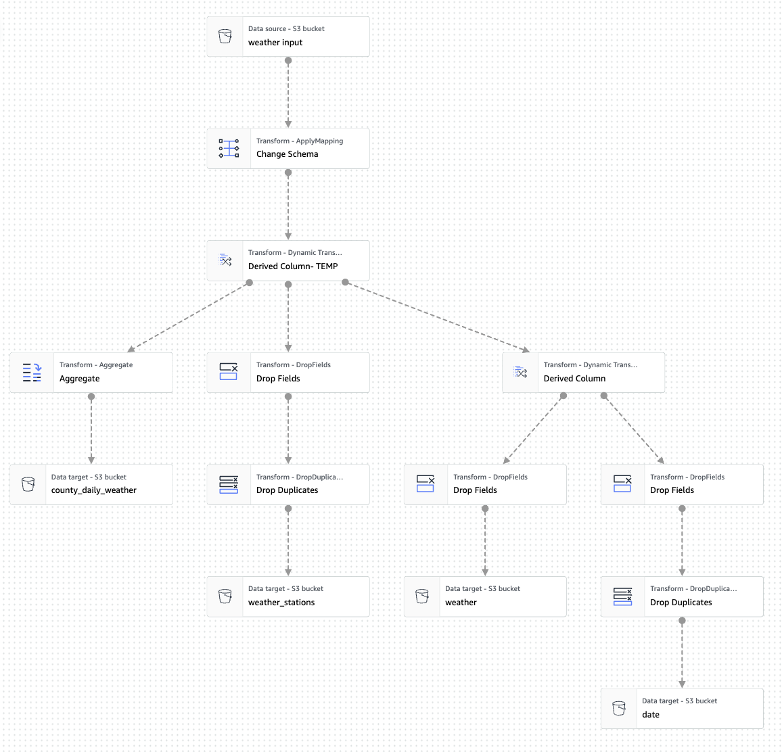

**Figure 47** ETL on Flood data

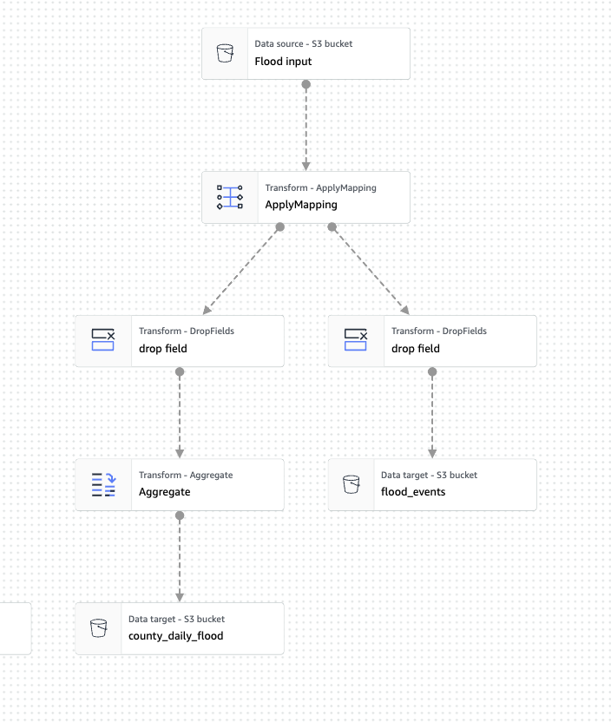

Some of the ETL operations that were performed on the data were changing schema, deriving custom columns, dropping fields, dropping duplicates, performing SQL Query and data aggregation.

Once all the virtual ETL gets connected the job needs to be run to perform the analysis. The execution of this operation took 4 min and 20 seconds as shown in the below Figure 48 The output operation from the ETL job will be 8 tables that will be stored in the S3 Bucket “Output” folder. This data will be used to perform further analysis.

**Figure 48** Successful execution of the ETL Job:

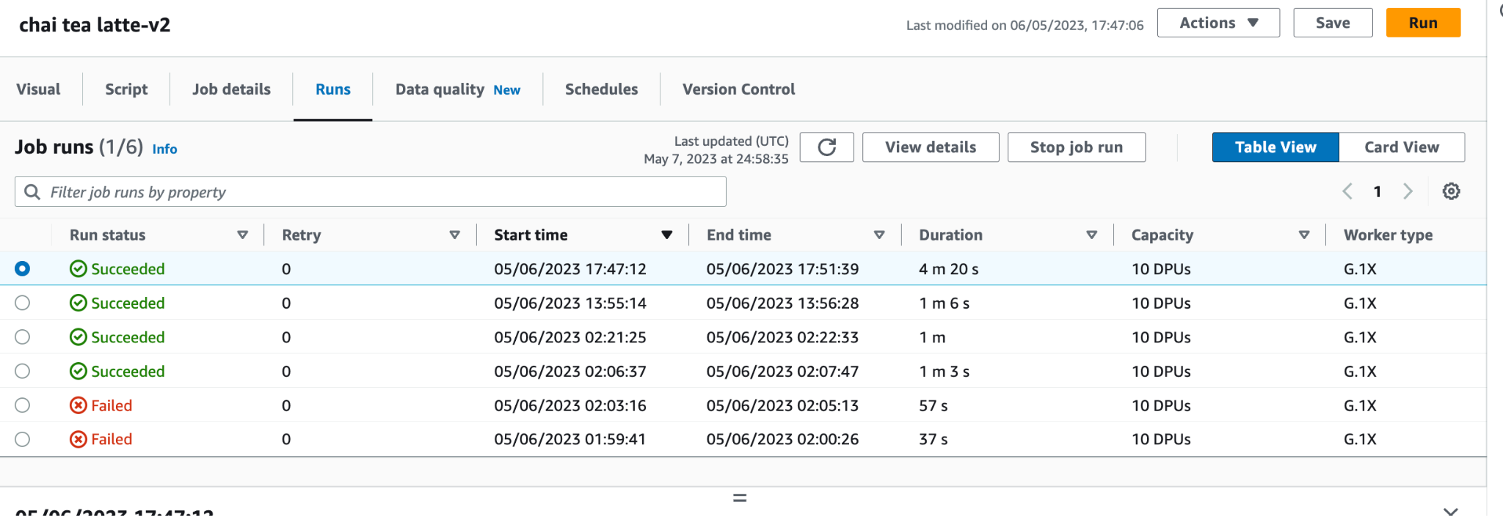

**Amazon S3 to Redshift : Data Export**

The cleaned tables which were obtained as a result of the ETL Glue jobs; were saved in the S3 bucket called “Output”, and imported into Amazon Redshift. This was done by creating an IAM role and associating it with the Redshift cluster for it to connect with the S3 bucket containing the tables. The import was performed using the COPY command, and we were able to successfully import the tables into Redshift.

**IAM Role Creation:**

To import cleaned tables into Redshift, we first created an IAM role named "s3toredshift". This role was granted two policies, AmazonRedshiftFullAccess and AmazonS3FullAccess as shown in Figure 49, to provide full access to both Amazon Redshift and S3. This was necessary to allow the role to access the S3 bucket containing the cleaned tables and to enable the Redshift cluster to communicate with the S3 bucket.

**Figure 49** IAM role created for S3 to redshift connection

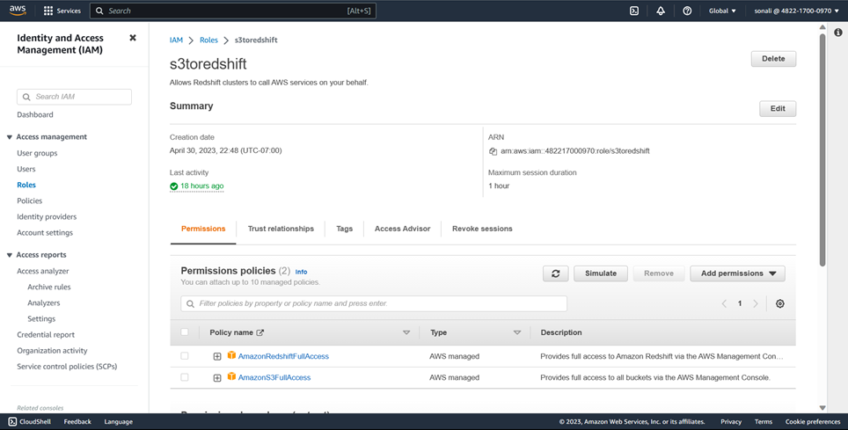

**Cluster Creation:**

Next, we created a Redshift cluster to facilitate the import. Refer Figure 50 and 51. We associated the previously created "s3toredshift" IAM role with the cluster during creation to grant it the necessary permissions to connect with the S3 bucket. We ensured that the cluster configuration was set appropriately to meet our requirements.

**Figure 50** Associating IAM role during cluster creation

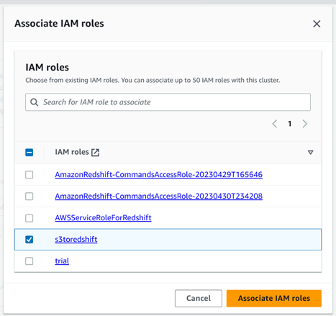

**Figure 51** Redshift cluster successfully created

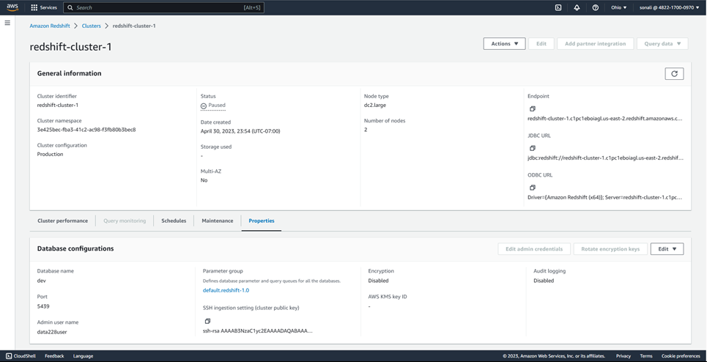

**Table Import:**

With the Redshift cluster in place, we were ready to import the cleaned tables from the S3 bucket into Redshift. We used the default database "dev", created schema for all the tables including relationship between the tables and executed the COPY command to import the tables into the aforementioned schema. The COPY command allowed us to specify the source of the data, the destination table, and other options required to ensure that the import was performed successfully. Refer Figure 52.

**Figure 52** Creating schema for S3 to Redshift import

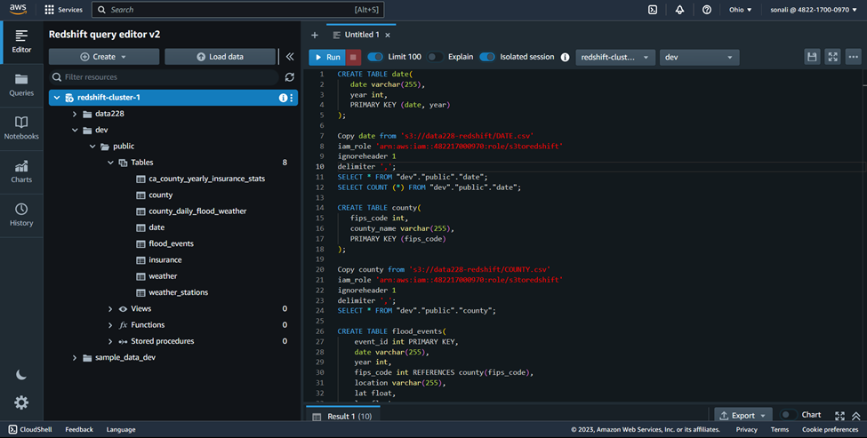

**Redshift to Tableau -**

After successfully importing the cleaned tables into Amazon Redshift, we proceeded to connect the database to Tableau for analytics and visualizations.

Inbound Rule Creation:

Before we could connect to the Redshift cluster from Tableau, we needed to create an inbound rule that allows all traffic. This was necessary to enable Tableau to access the database for analytics and visualizations. We ensured that the rule was added to the security group associated with the Redshift cluster. Refer Figure 53.

**Figure** **53** Adding inbound rule in cluster security group for connection to Tableau

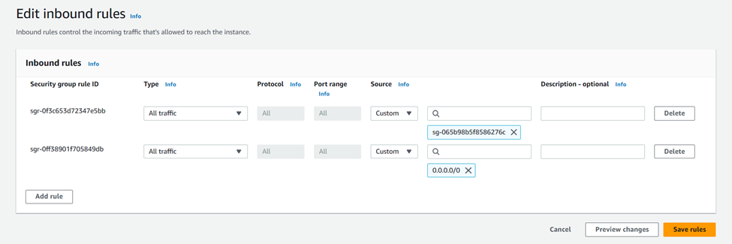

**Connecting to the Redshift Cluster:**

With the inbound rule in place, we could proceed to connect to the Redshift cluster using Tableau. We used the endpoint of the cluster, database name, username, and password to establish the connection. We ensured that the necessary drivers were installed and configured in Tableau to enable a successful connection. Refer Figure 54.

**Figure 54** Redshift to Tableau connection

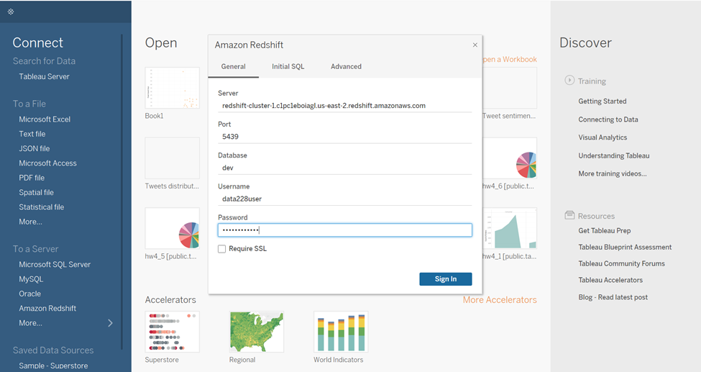

With the successful connection to the Redshift cluster, we could now start analyzing and visualizing the data in Tableau. Refer Figure 55 below.

**Figure 55** Tables Imported in Tableau

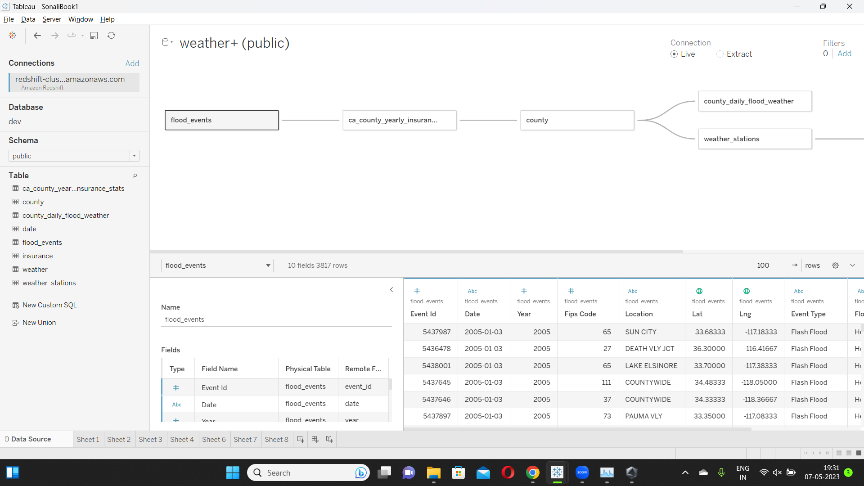

**Data Analytics- Tableau, Redshift Queries**

The visualization in Figure 56 depicts the total number of flood events by county. San Bernardino County is the hardest hit, while Alpine and Sierra counties are the least affected. This information can help with flood prevention and disaster management decisions.

**Figure 56** Visualization - Flood Count Per County Level

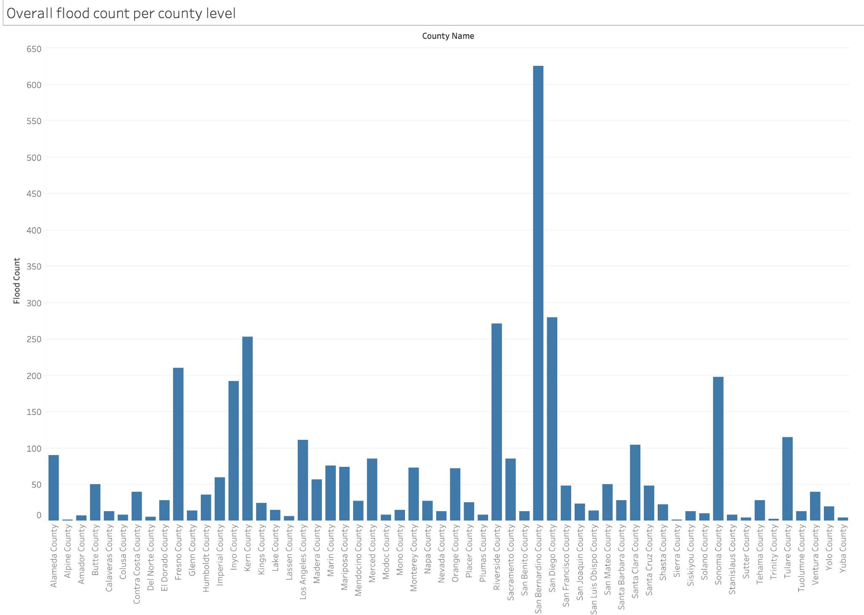

The map in Figure 57 compares the number of weather stations and flood events in each county, highlighting a disparity between wealthy and impoverished areas. Despite having fewer flood events, Los Angeles and Orange counties have nearly ten times the number of weather stations as San Bernardino County. Despite having fewer weather stations, San Bernardino County has five times the number of flood events as the other two counties.

**Figure 57** Visualization - Count of Flood Events vs Count of Weather Stations per County

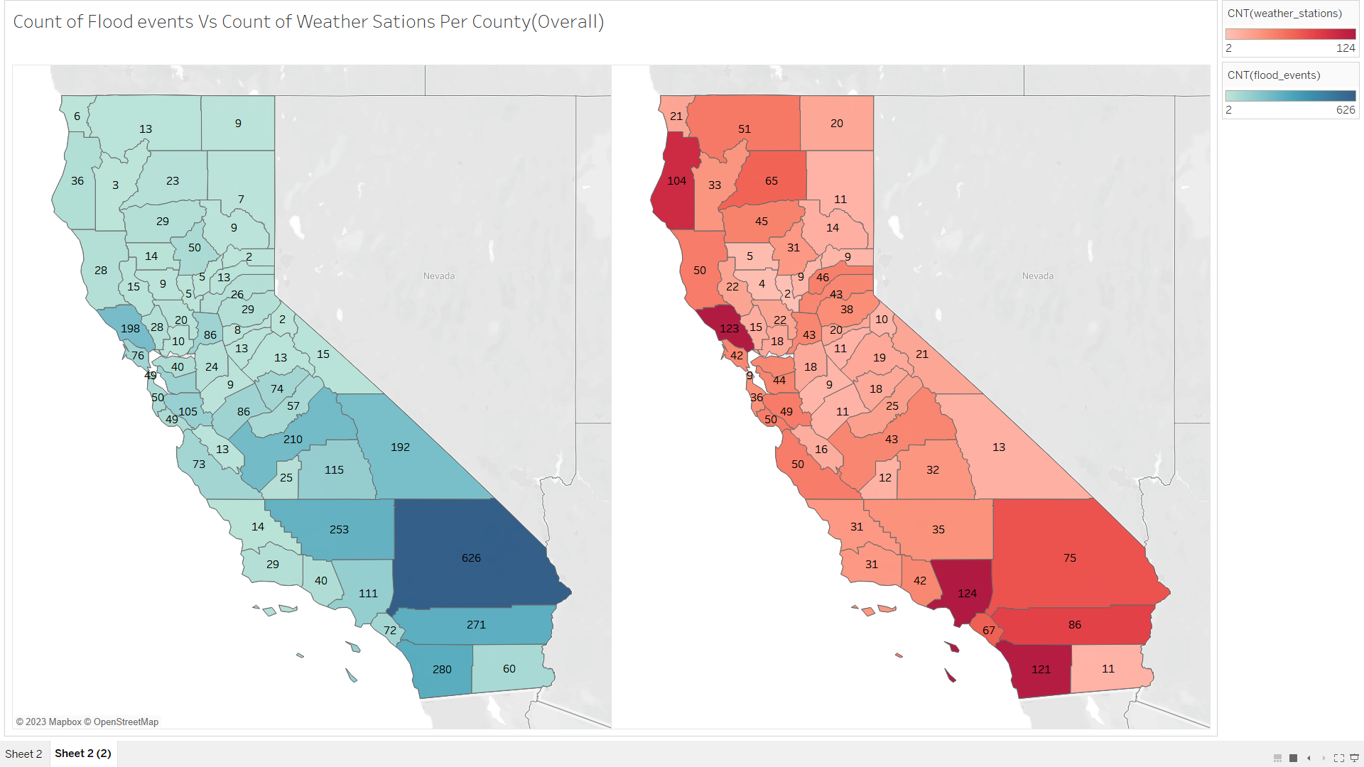

The new visualization in Figure 58 compares flood events and weather stations on an annual basis from 2005 to 2023. It draws attention to the disparity in the number of weather stations and flood events and allows users to track changes over time. This interactive feature can help identify areas that require additional disaster management strategies by providing valuable insights into the relationship between weather patterns and flood events.

**Figure 58** Visualization - Count of Flood Events vs Count of Weather Stations per County (In action)

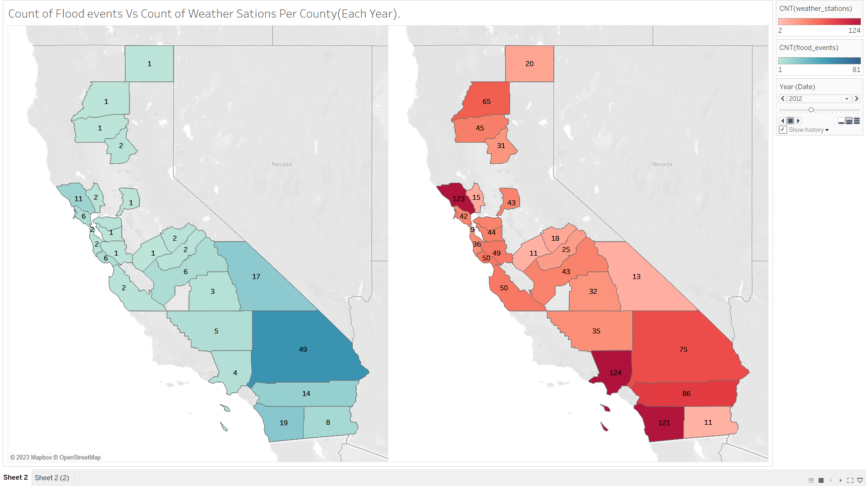

The graph in Figure 59 depicts the average precipitation and number of flood events in each county, revealing a disparity between wealthy and impoverished areas. Marin County, for example, receives a lot of rain but has fewer floods, whereas San Bernardino and Fresno counties have lower per capita income and more floods despite receiving less rain. This suggests that richer counties have historically had better drainage infrastructure than poorer counties, resulting in fewer flood events. In contrast, poorer counties' inadequate drainage infrastructure contributes to more floods.

**Figure 59** Visualization - Relationship between Flood Events, Precipitation & Income Levels

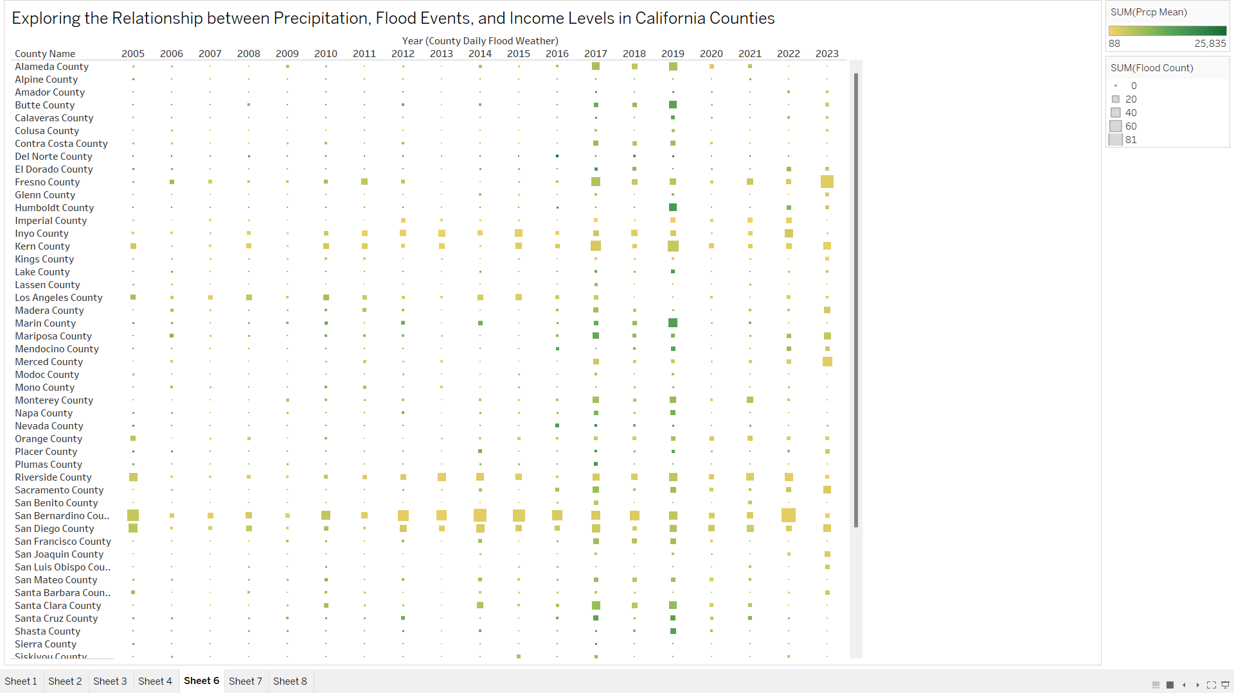

This graph in Figure 60 depicts the average logarithmic insured values for counties over a number of years. The term "average log insured" refers to the logarithmic average of insured values for properties or assets in a given region that are at risk of flooding. This metric can be used to assess the overall level of insurance coverage for a specific region. The visualization provides insights into the trends and patterns of insured values over time across different counties and can be useful for assessing the potential impact of floods on properties and assets.

**Figure 60** Visualization - Average Log Insured by Counties

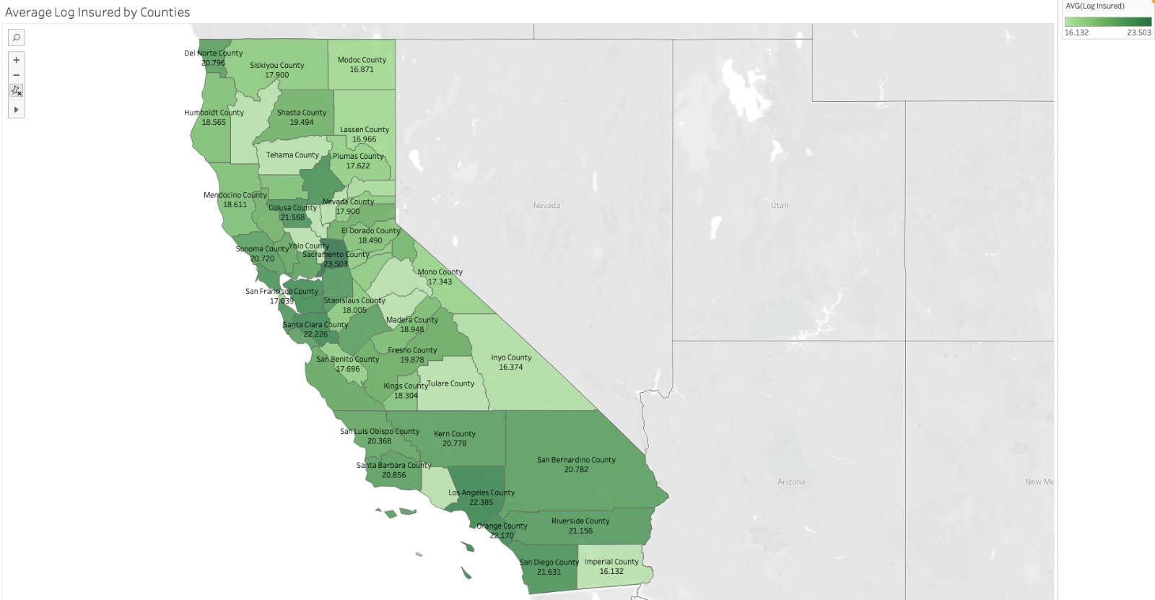

**5.1.7 Redshift Queries**

**Query 1**: This SQL query retrieves the total number of flood impact days and average precipitation for each county and year combination by joining the COUNTY, FLOOD_EVENT, DATE, WEATHER_STATION, and WEATHER tables. The results are organized by county name and year, and then ordered descendingly by total flood events. This query can provide information about the relationship between flood events and precipitation patterns in various counties over time. The result shows the total number of flood events in counties in a descending order with the average precipitation they received in the mentioned year.

**Figure 61** Query 1

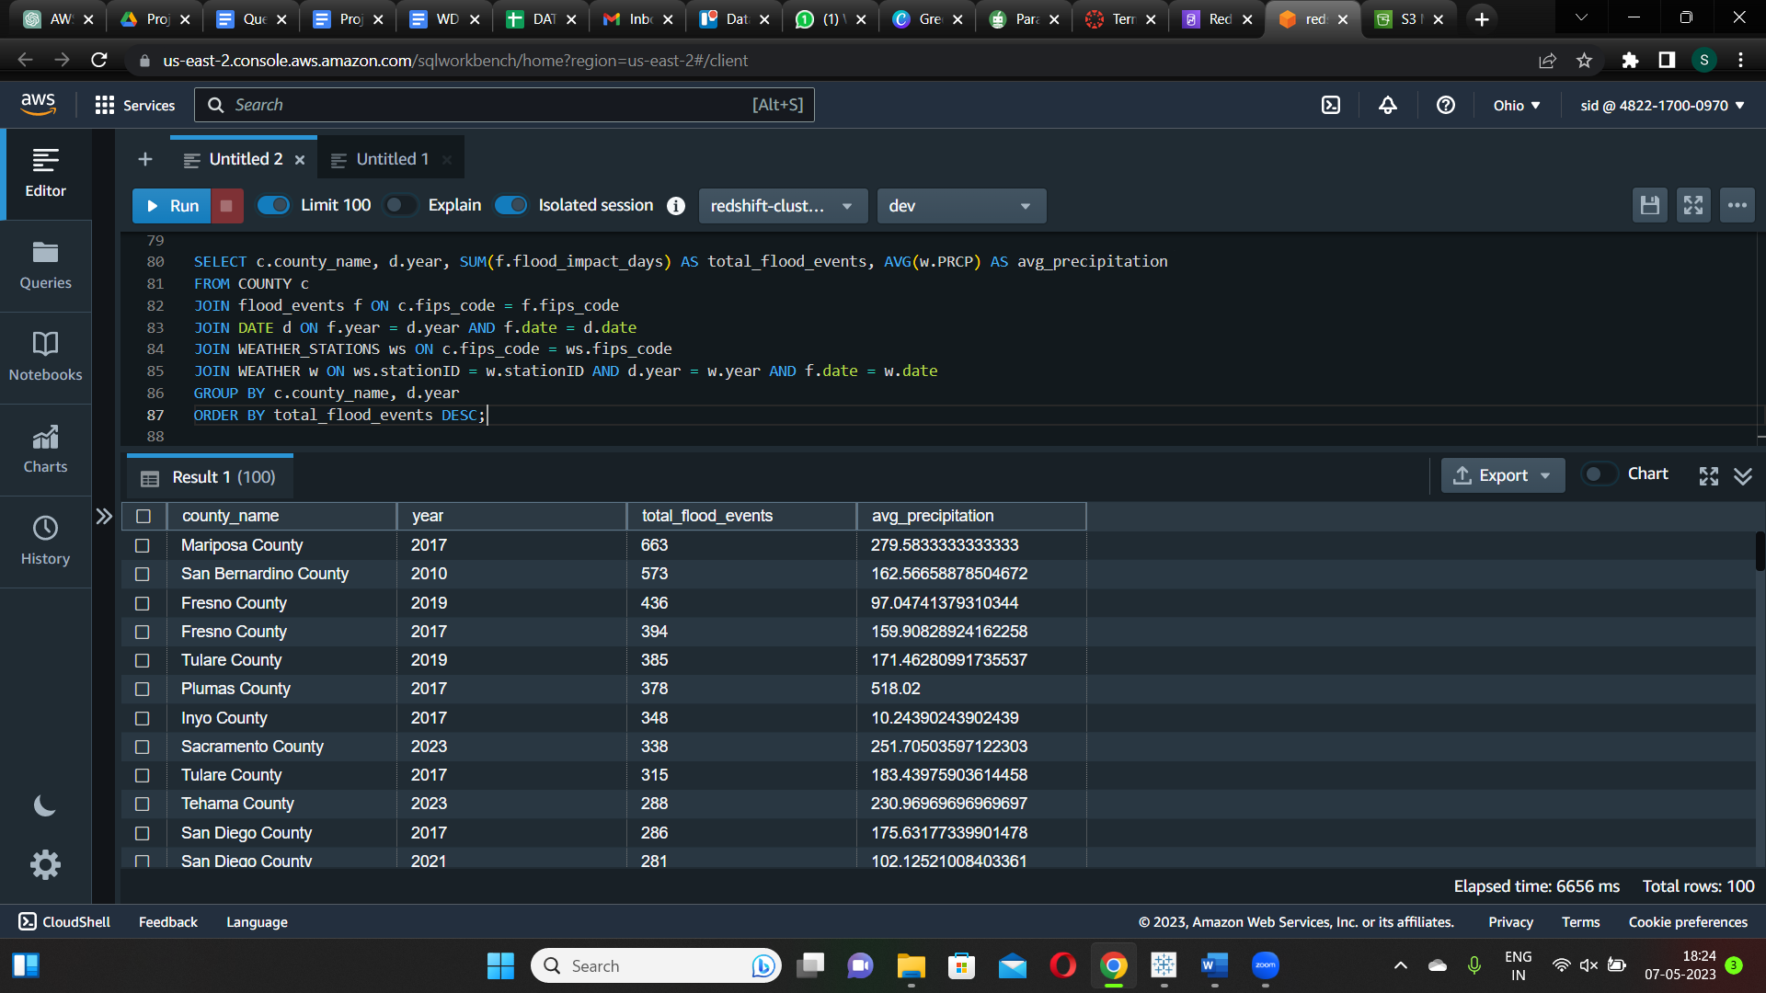

**Query 2**: The SQL query joins three tables to calculate the total number of insurance claims, total policy cost, and average policy cost per claim for each county in California for each year, as well as the total number of flood events and average flood count per day. The findings show a positive relationship between flood events and insurance claims, with more flood events leading to more insurance claims. This emphasizes the importance of mitigating the effects of flooding on communities and reducing the financial burden on individuals and insurers.

**Figure 62** Query 2

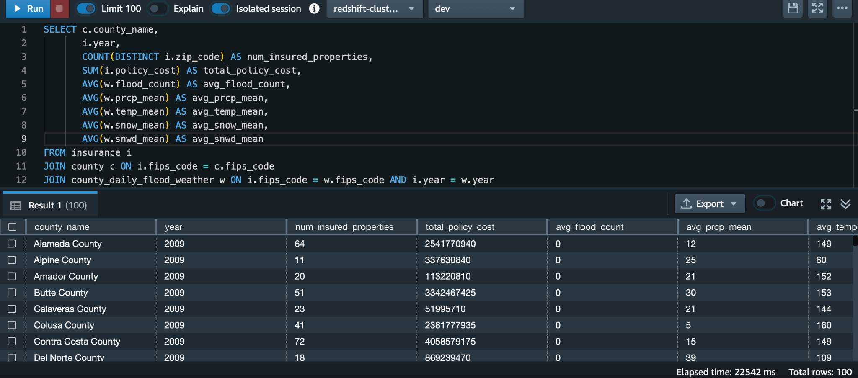

**Query 3**: The query returns the top 10 counties in California with the highest number of recorded flood events, along with the corresponding number of flood events in descending order. The result shows that San Bernardino County has the highest number of recorded flood events with 626 events, followed by San Diego County with 280 events and Riverside County with 271 events. This information could be useful for identifying areas where flood mitigation efforts may be most necessary.

**Figure 63** Query 3

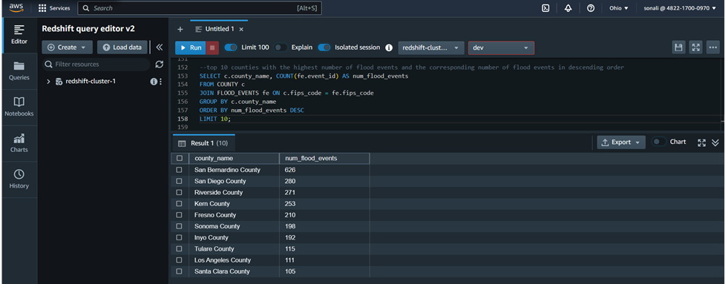

**Query 4**: This query returns the county in California with the highest average annual flood impact days. The result shows that Plumas County has the highest average annual flood impact days at 3 days. This information could be useful for identifying areas where flood insurance may be more necessary or where flood prevention measures may be needed.

**Figure 64** Query 4

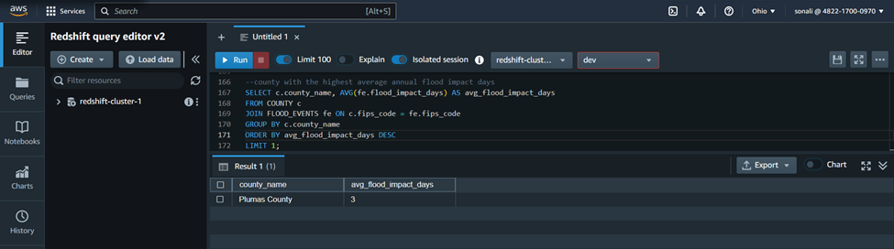

**Query 5**: The county, flood events, and California county insurance stats tables are joined in this SQL query to calculate the total number of flood events and total policy cost for each county in California for each year. The result shows the total number of flood over all the years from 2005-2023 and the total policy cost per year for a particular county.

**Figure 65** Query 5

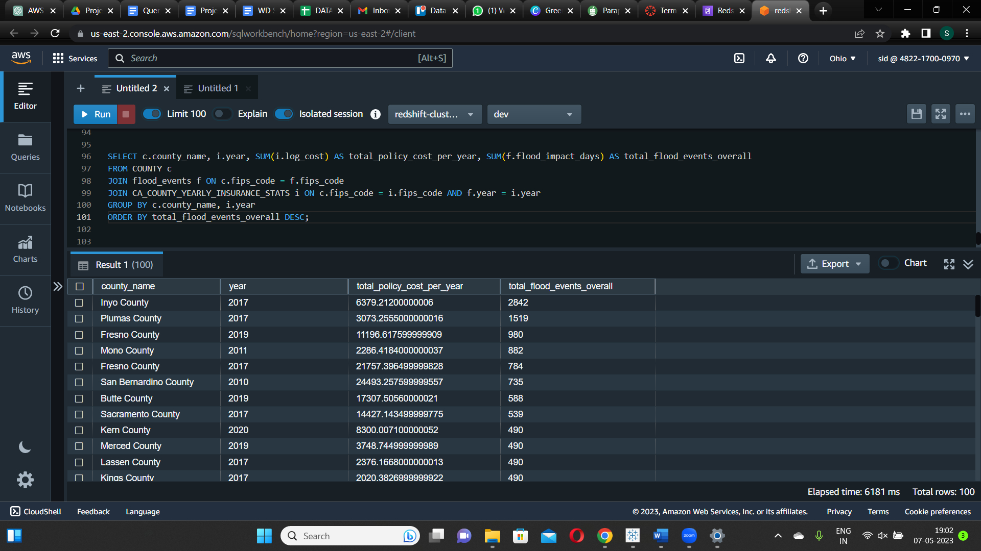

**5.2. System implementation issues and resolutions**

**Issue 1:**

One of the issues faced during the project implementations were, the failure of execution of Glue ETL job as mentioned in the Figure 66. The reason was because, the created IAM role will need additional permission to roll back the data from the glue job to the S3 Bucket. Hence an additional permission “AmazonS3FullAcess” needs to be given to the IAM role as mentioned in the Figure 67. Once the additional permission has been granted. The job ran without any error.

**Figure 66** Error shown while execution of the job

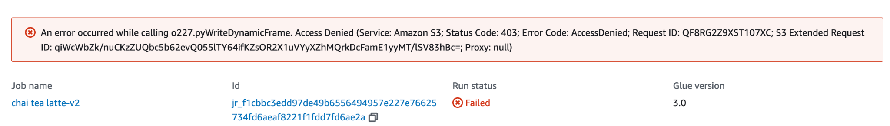

**Figure 67** Additional permission given to transfer data from glue to S3 Bucket

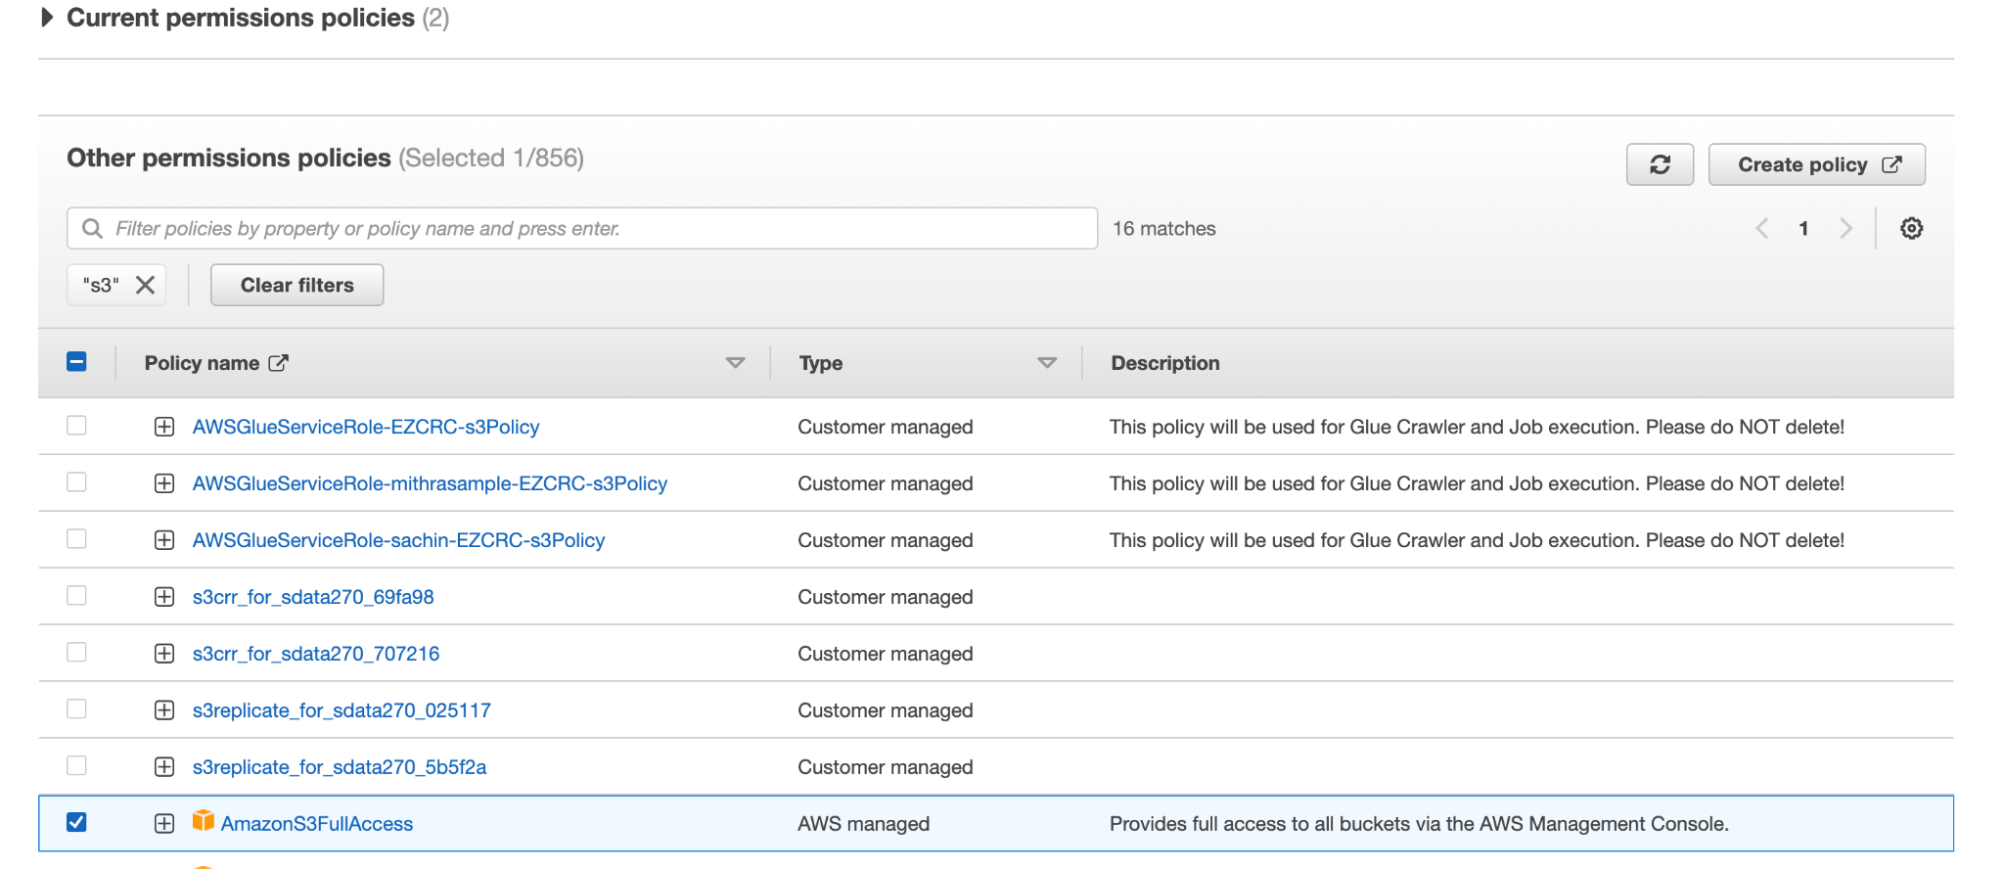

**Issue-2:**

Another issue faced was with data preprocessing. Python Pandas module was initially used to load the daset into the memory. The FEMA flood claims dataset, of size 16 GB took 45 minutes to just load the entire dataset into the memory. This added unnecessary time complexity to the project execution. This issue can be seen in the Github repository [7]. To overcome this issue we leveraged the use of an efficient data processing tool, PySpark. This significantly reduced the data processing times, and ensured efficient data pre-processing.

**Chapter 6. System Testing and Experiment**

**6.1 Testing and experiment scope**

Our data analysis project's test process and experiment scope include several stages such as connecting to various data sources, performing ETL jobs, creating a data warehouse, and visualizing the data using Tableau. We have identified specific test processes and objectives for each stage, as well as selected test criteria at the component and system levels. Each stage has its own test plan, complete with detailed test cases, procedures, and expected results. These test plans are carried out and monitored for failures, with corrective actions taken as needed.

Overall, we want to make sure the data analysis process is accurate, efficient, and dependable, and that the insights generated are useful for decision-making. For data processing, storage, and visualization, we use a combination of automated and manual testing methods, as well as AWS services such as Glue, Redshift, and S3. We hope to provide high-quality data analysis services to our clients and stakeholders through this rigorous testing and experimentation process, allowing them to make data-driven decisions with confidence.

**6.2 Testing and experiment approaches**

The use of test cases outlined in the test process and experiment scope will be included in the test plan. Functional testing, integration testing, and performance testing will be used to ensure that the S3 Glacier archival, AWS Glue ETL job, S3 to Redshift data loading, and Redshift to Tableau data visualization all work as expected. At both the component and system levels, selected test criteria will include accuracy, completeness, reliability, efficiency, maintainability, and usability. Furthermore, the test plan will include the use of automated testing tools to reduce manual errors and improve testing efficiency.

Overall, the test plan will be designed to validate the system's functionality, performance, and reliability while also ensuring compliance with the requirements and specifications outlined in the experiment scope. The test plan will be reviewed and updated on a regular basis to reflect any changes to the system or test requirements.

**6.3 Testing and experiment**

1. Testing pyspark support on Colab
2. Testing S3 Archival
3. Testing S3 Bucket
4. Testing Glue ETL
5. Testing Redshift Conn to S3 for loading data tables
6. Testing Redshift connection to Tableau

**Table 5: Testing connection between Google Colab and Google Drive**

| **Test No** | 1 |  |  |
| --- | --- | --- | --- |
| **Test Title** | Google Colab Connection to Google Drive | | |
| **Test Purpose** | Connect Google Colab to Google Drive | | |
| **Test Setup** | Google Colab, Google Drive | | |
| **Prerequisites** | Google Account with Google Drive access | | |
| **Procedure** | Use PyDrive to authenticate with Google Drive and establish a connection between the two platforms | | |
| **Checks** | Check if files can be uploaded and downloaded | | |
| **Expected Results** | Data can be uploaded and downloaded without any issues | | |
| **Result** | Data can be uploaded and downloaded without any issues | | |
| **Reason for Failure** | - | | |
| **Remarks** | Successfully completed | | |

**Table 6: Testing S3 Bucket**

| **Test No** | 2 |  |  |
| --- | --- | --- | --- |
| **Test Title** | AWS S3 Bucket | | |
| **Test Purpose** | To verify the successful replication of the parent S3 dataset to the replication buckets | | |
| **Test Setup** | AWS S3, S3 Buckets in US-East-2 region, US-West-1-Region | | |
| **Prerequisites** | The replication rule must be created in the parent S3 bucket. | | |
| **Procedure** | Add an object to the parent S3 bucket and check if it is replicated to the replication bucket. | | |
| **Checks** | Check the replication status of the object in the replication bucket | | |
| **Expected Results** | All objects should be successfully replicated to the replication bucket. | | |
| **Result** | All data objects were successfully replicated to the replication bucket. | | |
| **Reason for Failure** | - | | |
| **Remarks** | Successfully completed | | |

**Table 7: Testing S3 Glacier Archival System**

| **Test No** | 3 |  |  |
| --- | --- | --- | --- |
| **Test Title** | S3 Glacier Archival | | |
| **Test Purpose** | Check if data is properly archived to S3 Glacier | | |
| **Test Setup** | AWS S3, S3 Glacier | | |
| **Prerequisites** | Data in S3 input bucket, S3 Glacier vault created | | |
| **Procedure** | Use AWS CLI or boto3 library to transfer data from S3 input bucket to S3 Glacier vault | | |
| **Checks** | Verify the data transfer status and check if the data is properly archived in the S3 Glacier vault | | |
| **Expected Results** | All data from the input bucket should be properly transferred and archived in the S3 Glacier vault without any loss | | |
| **Result** | - | | |
| **Reason for Failure** | - | | |
| **Remarks** | Successfully Completed | | |

**Table 8: Testing AWS Glue ELT Job**

| **Test No** | 4 |  |  |
| --- | --- | --- | --- |
| **Test Title** | AWS Glue ETL Job | | |
| **Test Purpose** | Check if Glue ETL job is performing as expected | | |
| **Test Setup** | AWS Glue, S3, Redshift | | |
| **Prerequisites** | Data in S3 input buckets, Redshift Cluster | | |
| **Procedure** | Create a Glue ETL job and run it to load data from S3 to Redshift | | |
| **Checks** | Verify that the data has been loaded correctly and is consistent with the source data | | |
| **Expected Results** | Data should be loaded correctly and be consistent with the source data | | |
| **Result** | Data is loaded correctly and is consistent with the source data | | |
| **Reason for Failure** | - | | |
| **Remarks** | Successfully Completed | | |

**Table 9: Testing the connection between S3 and Redshift**

| **Test No** | 5 |  |  |
| --- | --- | --- | --- |
| **Test Title** | S3 to Redshift Connection | | |
| **Test Purpose** | Verify successful data load from S3 to Redshift | | |
| **Test Setup** | AWS S3, AWS Redshift | | |
| **Prerequisites** | S3 buckets with data, Redshift cluster created with target tables | | |
| **Procedure** | Use COPY command or Glue Job to load data from S3 to Redshift | | |
| **Checks** | Verify data in target Redshift tables and compare with S3 source data | | |
| **Expected Results** | Target Redshift tables are loaded with data from S3 buckets without any data loss | | |
| **Result** | Target Redshift tables are loaded with data from S3 buckets without any data loss. | | |
| **Reason for Failure** | - | | |
| **Remarks** | Successfully Completed | | |

**Table 10: Test connection between Redshift and Tableau**

| **Test No** | 6 |  |  |
| --- | --- | --- | --- |
| **Test Title** | AWS Redshift to Tableau Connection | | |
| **Test Purpose** | Check if data is properly flowing to Tableau | | |
| **Test Setup** | AWS Redshift, Tableau | | |
| **Prerequisites** | Data in S3 input buckets, Redshift Cluster | | |
| **Procedure** | Connect Redshift cluster with Tableau and write custom SQL query to obtain required data | | |
| **Checks** | Match Redshift analysis with Tableau graph outputs | | |
| **Expected Results** | Data flows properly to Tableau from the cluster and the performance is good | | |
| **Result** | Data flows properly to Tableau but there was performance issue since a huge amount of data was flowing, hence the graphs took time to load. | | |
| **Reason for Failure** | - | | |
| **Remarks** | Successfully Completed | | |

**Chapter 7. Conclusion and Future Work**

**7.1 Project summary**

We developed a comprehensive big data analytics platform that addresses the increasing severity and frequency of flooding events in California, while also tackling the decline in flood insurance policies. Utilizing climate data, flooding events data from NOAA, and insurance policies data from FEMA, the platform combined Spark with Python Programming on Google Colaboratory VMs for exploratory data analytics, Tableau for visual dashboards, and AWS technologies for data storage, ETL operations, and data warehousing. The result was a data-driven solution that informed flood-emergency preparedness, promoted flood insurance awareness, and guided policy-making decisions on a county-level granularity.

The project's main contributions includes proposing a big data analytics system design for processing and analyzing large volumes of climate and flood insurance transaction data, developing a data warehouse solution that supports the creation of new flood risk assessment models, and providing insights through Tableau dashboards for developing new flood insurance policies and programs.

The project has both technical and societal impacts, as it offers a scalable and extendable solution that could be applied to other natural disaster risk management domains and could provide valuable insights for residents, policymakers, and industry professionals. The project deliverables include a detailed report, a web portal with Single-Sign-On functionality for authorized users, and documented code on GitHub. Market research conducted for this project identified gaps in existing solutions, enabling the development of a one-stop solution that offered actionable data-driven insights for effective flood-related policy-making.

**7.2 Future work**.

The current project is concentrated on analyzing California data exclusively, but expanding the project's scope to cover the entire USA would be beneficial to more stakeholders. Furthermore, presently only weather and flood data are included, but the project's domain can be broadened by incorporating river and stormwater information as well. Additionally, grammatical errors have been corrected.

**REFERENCES**

1. Wikipedia contributors. (2023). List of counties in California. *Wikipedia*. https://en.wikipedia.org/wiki/List_of_counties_in_California
2. Good360. (2023, March 2). *2023 California Floods - Good360*. https://good360.org/disaster-recovery/california-floods/
3. NCEI.Monitoring.Info@noaa.gov. (n.d.). *Billion-Dollar Weather and Climate Disasters | National Centers for Environmental Information (NCEI)*. https://www.ncei.noaa.gov/access/billions/
4. Jaylund, V. a. P. B. (2019, June 14). *Flood Mapping in California: The Good, the Bad, and the Ugly*. California WaterBlog. https://californiawaterblog.com/2019/06/16/flood-mapping-in-california-the-good-the-bad-and-the-ugly
5. *FEMA Updates Flood Maps in Riverside and San Bernardino counties and the cities of Chino, Chino Hills, Colton, Corona, Eastvale, Jurupa Valley, Norco, Ontario, Rialto and Riverside*. (2023, March 3). FEMA.gov. https://www.fema.gov/press-release/20230306/fema-updates-flood-maps-riverside-and-san-bernardino-counties-and-cities
6. OpenAI. (2021). GPT-3.5. [Computer software]. GitHub repository, https://github.com/openai/gpt-3
7. Skwolvie. (n.d.). *GitHub - skwolvie/BigData-BayWatch-CaliFloodsEdition: Data 228 Course project - Spring 2023. Team Chai Tea Latte*. GitHub. https://github.com/skwolvie/BigData-BayWatch-CaliFloodsEdition
8. *Flood Maps*. (n.d.). FEMA.gov. https://www.fema.gov/flood-maps
9. *FEMA Flood Map Service Center | Search By Address*. (n.d.). https://msc.fema.gov/portal/search?AddressQuery=California
10. *Map | National Risk Index*. (n.d.). https://hazards.fema.gov/nri/map
11. *Historical Flood Risk and Costs*. (n.d.). FEMA.gov. https://www.fema.gov/data-visualization/historical-flood-risk-and-costs
12. *Tableau: Business Intelligence and Analytics Software*. (n.d.). Tableau. https://www.tableau.com/
13. NCEI.Monitoring.Info@noaa.gov. (n.d.-b). *Billion-Dollar Weather and Climate Disasters | National Centers for Environmental Information (NCEI)*. https://www.ncei.noaa.gov/access/billions/mapping
14. Ncei. (n.d.). *Storm Events Database | National Centers for Environmental Information*. https://www.ncdc.noaa.gov/stormevents/choosedates.jsp?statefips=6%2CCALIFORNIA#
15. *Climate Data Records*. (n.d.). National Centers for Environmental Information (NCEI). https://www.ncei.noaa.gov/products/climate-data-records
16. *FIMA NFIP Redacted Policies - v1*. (n.d.). FEMA.gov. https://www.fema.gov/openfema-data-page/fima-nfip-redacted-policies-v1
17. Wing, O. E. J., Pinter, N., Bates, P. D., & Kousky, C. (2020). New insights into US flood vulnerability revealed from flood insurance big data. *Nature Communications*, *11*(1). https://doi.org/10.1038/s41467-020-15264-2
18. Kijewski-Correa, T., Taflanidis, A. A., Vardeman, C., Sweet, J. A., Zhang, J., Snaiki, R., Wu, T., Silver, Z., & Kennedy, A. B. (2020). Geospatial Environments for Hurricane Risk Assessment: Applications to Situational Awareness and Resilience Planning in New Jersey. *Frontiers in Built Environment*, *6*. https://doi.org/10.3389/fbuil.2020.549106
19. *Calculation and Comparison of the Flood Risk Potential Due to Rainfall Events and Snow Melt Using Techniques Developed for Flood Risk in Florida - ProQuest*. (n.d.). https://www.proquest.com/openview/817cfd7db3f802fd621ee5050185ef2c/1?pq-origsite=gscholar&cbl=18750&diss=y
20. Assi, A. A., Mostafiz, R. B., Friedland, C. J., Rahim, M. A., & Rohli, R. V. (2023). Flood risk assessment for residences at the neighborhood scale by owner/occupant type and first-floor height. *Frontiers in Big Data*, *5*. https://doi.org/10.3389/fdata.2022.997447
21. Donratanapat, N., Samadi, S., Vidal, J. L. M., & Tabas, S. S. (2020). A national scale big data analytics pipeline to assess the potential impacts of flooding on critical infrastructures and communities. *Environmental Modelling and Software*, *133*, 104828. https://doi.org/10.1016/j.envsoft.2020.104828

**APPENDIX**

**Appendix A – Purchase Recipt of Google Colaboratory**

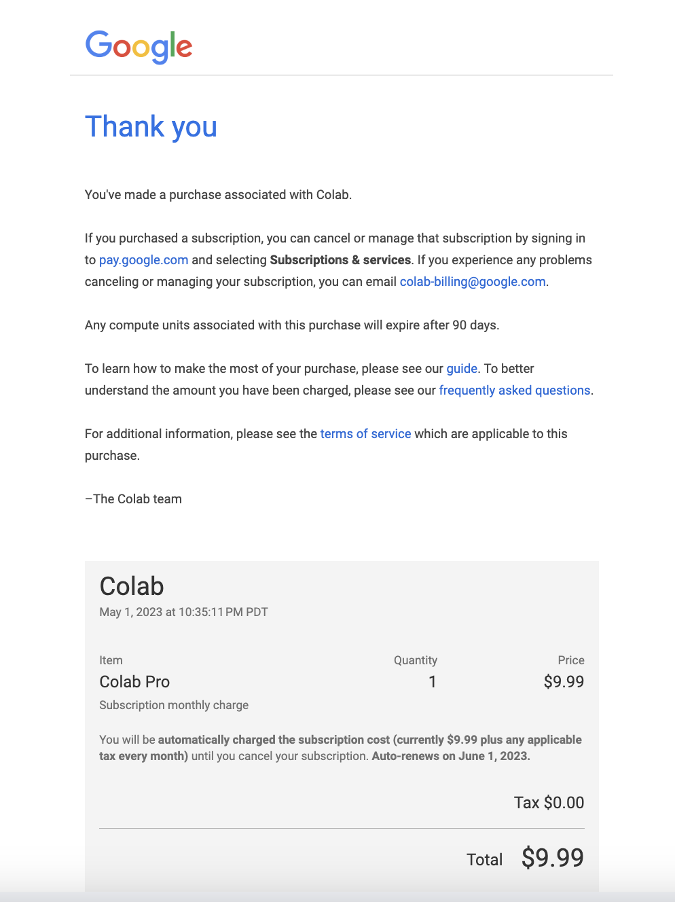

**Appendix B – Estimated Monthy and Year-round Cost for AWS S3**

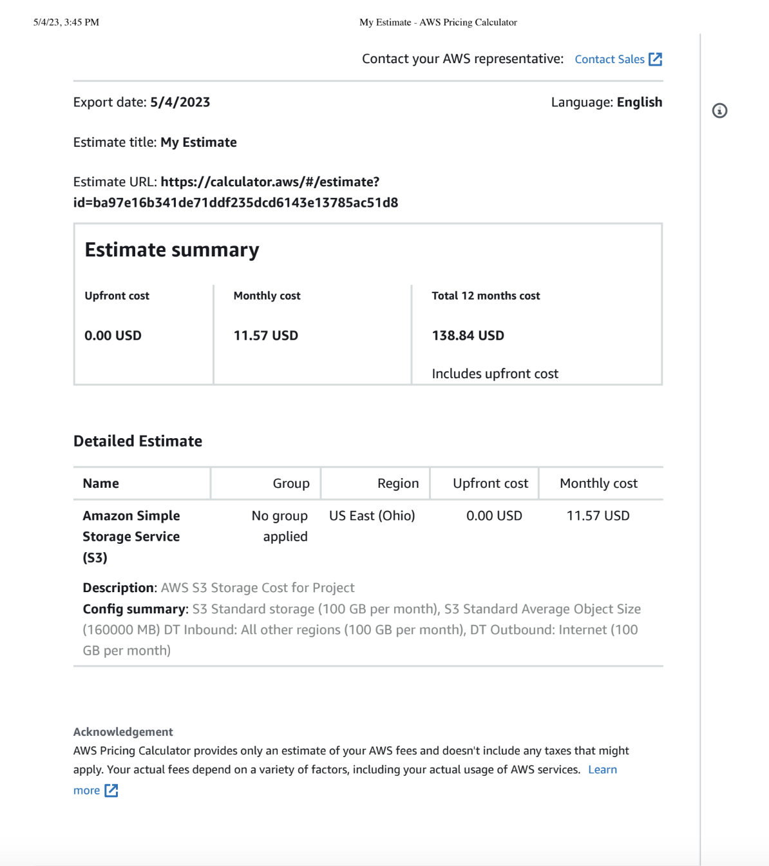

**Appendix C – Estimated Monthy and Year-round Cost for AWS Redshift**

